PROJECT REPORT

On

MediStock : Medicine Stock Intelligence

Submitted by

Yug Ashwin Patel (IU2341230117)

In fulfillment for the award of the degree

Of

BACHELOR OF TECHNOLOGY

In

COMPUTER SCIENCE ENGINEERING



INSTITUTE OF TECHNOLOGY AND ENGINEERING
INDUS UNIVERSITY CAMPUS, RANCHARDA, VIA-THALTEJ
AHMEDABAD-382115, GUJARAT, INDIA,
WEB: www.indusuni.ac.in
OCT 2026

PROJECT REPORT
ON
MediStock : Medicine Stock Intelligence


In the fulfilment of the requirement
for the degree of
Bachelor of Technology
in
Computer Science & Engineering
PREPARED BY
Yug Ashwin Patel (IU2341230117)
UNDER GUIDANCE OF
Internal Guide
Ms Sweta Rathod
Assistant Professor, Department of Computer Engineering,
I.T.E, Indus University ,Ahmedabad

Department of Computer Science & Engineering,
I.I.T.E, Indus University, Ahmedabad
SUBMITTED TO
INSTITUTE OF TECHNOLOGY AND ENGINEERING
INDUS UNIVERSITY CAMPUS, RANCHARDA, VIA-THALTEJ
AHMEDABAD-382115, GUJARAT, INDIA,
WEB: www.indusuni.ac.in
OCT 2026

CANDIDATE’S DECLARATION
I declare that the final report entitled “MediStock : Medicine Stock Intelligence – A Smart Pharmacy & Hospital Inventory Management System” is my own work conducted under the supervision of my internal guide Sweta Rathod.
I further declare that to the best of my knowledge, the report for B.Tech Internship-2 (CE0523) does not contain part of the work which has been submitted for the award of B.Tech Degree either in this university or any other university without proper citation.
___________________________________
Candidate’s Signature
Yug Ashwin Patel (IU2341230117)

Guide: ______________________________
Ms Sweta Rathod
Assistant Professor,
Department of Computer Science & Engineering
Indus Institute of Technology and Engineering
INDUS UNIVERSITY – Ahmedabad,
State: Gujarat

INDUS INSTITUTE OF TECHNOLOGY AND ENGINEERING
COMPUTER SCIENCE & ENGINEERING
OCT 2026


CERTIFICATE

Date: __/10/2026

This is to certify that the Software Group Project work entitled “ MediStock - Medicine Stock Intelligence ” has been carried out by Yug Patel under my guidance in partial fulfillment of the requirements for the Bachelor of Technology in Computer Science and Engineering (Final Year) of Indus University, Ahmedabad during the academic year 2026.

______________________  Ms Sweta Rathod  Assistant Professor,  Department of Computer Science and Engineering,  IITE, Indus University,  Ahmedabad. | ______________________  Dr. Kaushal Jani  Head of Department,  Department of Computer Science and Engineering,  IITE, Indus University,  Ahmedabad.

ACKNOWLEDGEMENT
Towards the successful completion of my B.Tech in Computer Science & Engineering internship, I would like to express my heartfelt gratitude to all those who contributed to this journey.
First and foremost, I extend my sincere appreciation to my institution and faculty members for equipping me with the knowledge and skills necessary to undertake this internship. Their guidance throughout my academic journey has been invaluable.
I am also grateful to the mentors and colleagues at the organization where I carried out my internship, whose guidance, discussions, and support played a crucial role in overcoming challenges and successfully completing the MediStock : Medicine Stock Intelligence project. Their willingness to share industry insights, best practices, and practical knowledge significantly enhanced my understanding of how theoretical concepts translate into working solutions. The collaborative environment fostered learning through peer interactions, code reviews, and constructive feedback that refined both my technical abilities and professional approach. Their patience in addressing my queries and their encouragement during difficult phases made the learning experience both enriching and memorable.
Furthermore, I express my heartfelt gratitude to my internal guide at the college, whose constant mentorship and invaluable expertise were indispensable in executing this work successfully. Their timely suggestions, critical reviews, and encouragement during challenging phases kept me motivated and on track. The regular discussions and progress evaluations helped me maintain focus on the project objectives while ensuring adherence to academic standards and quality expectations. Their door was always open whenever I needed advice or clarification, and their dedication to student success is truly commendable.
- Yug Ashwin Patel
IU2341230117
Computer Science & Engineering
TABLE OF CONTENT
Title Page No
ABSTRACT viii
LIST OF FIGURES ix
LIST OF TABLES x
CHAPTER 1 INTRODUCTION 1-8
1.1 Project Summary 2
1.2 Project Purpose 2
1.3 Project Scope 3
1.4 Objectives 4
1.4.1 Main Objectives 4
1.4.2 Secondary Objectives 4
1.5 Technology and Tools 4
1.5.1 Front-End Technology 5
1.5.1.1 React / Vite (JavaScript) 5
1.5.1.2 HTML / CSS (Duckett, 2011) 5
1.5.1.3 CSS / Bootstrap 5
1.5.1.4 Axios (HTTP Client) 6
1.5.1.5 Chart.js 6
1.5.2 Back-End Technology 6
1.5.2.1 Node.js / Express 6
1.5.2.2 JSON 7
1.5.3 Database 7
1.5.3.1 MongoDB (Mongoose ORM) 7
1.6 Synopsis 7
CHAPTER 2 LITERATURE SURVEY 9-21
2.1 Introduction of Survey 10
2.2 Why Survey? 10
2.3 Existing System VS Proposed System 11
2.4 Types of Inventory Management Systems and Their Advantages and Weaknesses 12
2.4.1 Analytical IMS 12
2.4.2 Collaborative IMS (CIMS) 12
2.4.3 Operational IMS (OIMS) 13
2.5 Case Study of Popular Operational Inventory Management Systems 14
2.5.1 Meditech Inventory Management 14
2.5.2 Oracle Health Inventory Management 15
2.5.3 OpenMRS / GNU Health 16
2.5.4 Infor CloudSuite Healthcare 17
2.5.5 Marg ERP (Pharmacy) 19
2.5.6 PharmAssist / MedEase 19
2.5.7 MedTrack Pro 20
CHAPTER 3 PROJECT MANAGEMENT 22-29
3.1 Project Planning Objectives 23
3.1.1 Software Scope 23
3.1.2 Resources 23
3.1.2.1 Human Resource 23
3.1.2.2 Reusable Software Resource 24
3.1.2.3 Environment Resource 24
3.1.3 Project Development Approach 24
3.2 Project Scheduling 25
3.2.1 Basic Principle Scope 25
3.2.2 Compartmentalization Scope 25
3.2.3 Work Breakdown Structure 26
3.2.4 Project Organization 26
3.2.5 Timeline Chart 26
3.2.5.1 Time Allocation Chart 26
3.2.5.2 Task Sets 27
3.3 Risk Management 28
3.3.1 Risk Identification 28
3.3.1.1 Risk Identification Artifacts 28
3.3.2 Risk Projection 28
CHAPTER 4 SYSTEM REQUIREMENTS 30-35
4.1 User Characteristics 31
4.1.1 Target Audience 31
4.1.2 Target Audience Needs 32
4.2 Functional Requirement 33
4.2.1 Activity and Proposed System 33
4.3 Non-Functional Requirement 34
4.4 Hardware and Software Requirement 34
4.4.1 Hardware Requirement 34
4.4.2 Software Requirement 34
4.4.3 Server Hosting Requirement 35
CHAPTER 5 SYSTEM ANALYSIS 36-41
5.1 Study of Current System 37
5.1.1 Importance of Inventory Management in Healthcare 37
5.1.2 IMS Implementation Challenges 37
5.1.3 Popular IMS Platforms 38
5.2 Problems in Current System 38
5.3 Requirement of New System 38
5.4 Process Model 39
5.5 Feasibility Study 39
5.5.1 Technical Feasibility 39
5.5.2 Operational Feasibility 40
5.5.3 Economic Feasibility 40
5.5.4 Schedule Feasibility 40
5.5.5 Legal Feasibility 40
5.6 Features of New System 41
CHAPTER 6 SYSTEM DESIGN 42-57
6.1 Class Diagram 43
6.2 Use Case Diagram 44
6.3 Sequence Diagram 45
6.4 Activity Diagram 46
6.5 Entity-Relationship Diagram 47
6.6 Context Diagram 48
6.7 Data Flow Diagram 49
6.8 Data Dictionary 52
6.8.1 Collection: medicines 52
6.8.2 Collection: users 53
6.8.3 Collection: audit_logs 53
6.8.4 Collection: purchase_orders 54
6.8.5 Collection: suppliers 54
6.8.6 Collection: categories 55
6.8.7 Collection: inventory_movements 56
6.8.8 Collection: reports 56
6.8.9 Collection: forecasts 57
6.8.10 Collection: settings 57
CHAPTER 7 TESTING 58-63
7.1 Black-Box Testing 59
7.2 White-Box Testing 59
7.3 Test Cases 60
7.3.1 Test Summary 61
7.3.2 Test Environment 61
7.3.3 Functional Test Cases 62
7.3.4 Non-Functional Testing 63
7.3.5 Defects and Observations 63
7.3.6 Test Conclusion 63
CHAPTER 8 RESULT AND DISCUSSION 64-68
8.1 Login, Registration and Email Verification Module 65
8.2 Dashboard Module 65
8.3 Medicine Module 66
8.4 Purchase Order Module 66
8.5 Supplier Module 67
8.6 Prediction Module 67
8.7 Medicine Category Module 67
8.8 Audit Log Module 67
8.9 Report and Import / Export Module 68
8.10 Summary of Results 68
CHAPTER 9 LIMITATIONS AND FUTURE ENHANCEMENT 69-71
9.1 Limitations 70
9.2 Future Enhancement 70
CHAPTER 10 CONCLUSION 72-73
10.1 Conclusion 73
REFERENCES 74
APPENDIX A: ABBREVIATIONS 80

ABSTRACT
The MediStock : Medicine Stock Intelligence is an online tool designed to manage pharmacy and hospital medicine inventory operations. It focuses on modules like medicine management, supplier management, purchase orders, demand forecasting, expiry and stock alerts, audit logs, CSV/XLSX import/export, and PDF report generation. By consolidating these essential functions into a single unified platform, the system eliminates the need for multiple disconnected tools and manual record-keeping.
Healthcare inventory management systems are integral to hospital and pharmacy operations, focusing specifically on ensuring the right medicines are available in the right quantity at the right time, while minimizing wastage due to expiry and overstocking. Inefficient inventory practices can lead to critical medicine shortages, financial losses from expired stock, and compromised patient care. An intelligent, data-driven approach to inventory management addresses these challenges by providing actionable insights and automated alerts that enable proactive decision-making.
The system architecture follows the MERN stack (MongoDB, Express.js, React, Node.js), ensuring scalability, maintainability, and seamless integration with existing healthcare IT infrastructure. The backend RESTful API handles business logic, data validation, and secure authentication, while the frontend delivers an intuitive dashboard with interactive visualizations and drill-down analytics. Role-based access control ensures that different user groups, such as pharmacists, administrators, and procurement officers, have appropriate permissions tailored to their responsibilities.
Currently in its beta version, the system is continually evolving, with plans to introduce advanced AI-powered demand forecasting, integration with national drug databases, and multi-branch pharmacy support. Future enhancements also include mobile application compatibility, barcode scanning for rapid inventory updates, predictive analytics for seasonal demand patterns, and integration with electronic health record (EHR) systems for holistic healthcare management.
Keywords: MediStock : Medicine Stock Intelligence, Demand Forecasting, Shortage Risk Scoring, Healthcare Inventory Management, MERN Stack Real-time Tracking, Supply Chain Optimization .

LIST OF FIGURES
Figure No Title Page No.
Fig 2.1 Benefits of Medicine Inventory Management Software (Source: Vaidya, 2020) 14
Fig 2.2 Screenshot of Meditech Inventory Management 15
Fig 2.3 Screenshot of Oracle Health Inventory Management 16
Fig 2.4 OpenMRS Inventory Dashboard 17
Fig 2.5 Screenshot of Infor CloudSuite Healthcare Dashboard 18
Fig 2.6 Screenshot of Marg ERP Pharmacy 19
Fig 2.7 Screenshot of PharmAssist Dashboard 20
Fig 2.8 Screenshot of MedTrack Pro 21
Fig 3.1.3.1 SDLC 25
Fig 3.2.5.1 Time Allocation Chart (Gantt Chart) 27
Fig 5.4.1 Incremental Model 39
Fig 6.1.1 Class Diagram 43
Fig 6.2.1 Admin Use Case Diagram 44
Fig 6.3.1 Sequence Diagram 45
Fig 6.4.1 Activity Diagram 46
Fig 6.5.1 Entity-Relationship Diagram 47
Fig 6.6.1 Context Diagram 48
Fig 6.7.1 Data Flow Diagram LEVEL-0 49
Fig 6.7.2 Data Flow Diagram LEVEL-1 50
Fig 6.7.3 Data Flow Diagram LEVEL-1 50
Fig 6.7.4 Data Flow Diagram LEVEL-2 51
Fig 6.7.5 Data Flow Diagram LEVEL-2 51

LIST OF TABLES
Table No Title Page No.
Table 3.2.3.1 Work Breakdown Structure 26
Table 3.2.5.1 Task Sets 27
Table 3.3.2.1 Risk Projection 28
Table 6.8.1 Collection Schema: medicines 52
Table 6.8.2 Collection Schema: users 53
Table 6.8.3 Collection Schema: audit_logs 53
Table 6.8.4 Collection Schema: purchase_orders 54
Table 6.8.5 Collection Schema: suppliers 54
Table 6.8.6 Collection Schema: categories 55
Table 6.8.7 Collection Schema: categories (Type Classification) 55
Table 6.8.8 Collection Schema: inventory_movements 56
Table 6.8.9 Collection Schema: reports 56
Table 6.8.10 Collection Schema: forecasts 57
Table 7.3.1 Testing Report 61
Table 7.3.2 Test Environment 61
Table 7.3.3 Functional Test Cases 62
Table 7.3.4 Non-Functional Testing 63
Table 8.10.1 Summary of Results 68
Chapter 1
Introduction
1.1 Project Summary
1.2 Project Purpose
1.3 Project Scope
1.4 Objectives
1.5 Technology and Tools
1.6 Synopsis
Chapter 1

INTRODUCTION

1.1 PROJECT SUMMARY
The proposed MediStock : Medicine Stock Intelligence portal is an online tool designed to manage healthcare inventory operations. It focuses on modules like medicine tracking, stock alerts, supplier management, purchase orders, demand forecasting, audit logs, and comprehensive reporting.
Inventory Management Systems (IMS) are software tools with multiple modules that keep track of stock levels, expiry dates, supplier details, and purchasing workflows. Modern healthcare institutions require efficient IMS solutions to prevent medicine shortages, reduce wastage from expired stock, and ensure regulatory compliance.
The proposed MediStock : Medicine Stock Intelligence system is designed to address the challenges in pharmacy and hospital medicine inventory management. It allows healthcare facilities to track real-time medicine stock, manage suppliers and purchase orders, predict demand based on historical consumption, send expiry and low-stock alerts, import/export data via CSV/XLSX, and generate detailed PDF reports.
MediStock is built on the MERN stack (MongoDB, Express.js, React and Node.js). Access is role based, so that Admin, Manager, Pharmacist and Cashier users see only the modules that belong to their work. The core modules are medicine and inventory management with batch numbers, expiry dates and automatic stock status, category management, supplier management, purchase orders, demand forecasting with shortage risk scoring, expiry and low-stock alerts, audit logs, CSV/XLSX import and export, and PDF/XLSX report generation. All modules share one database, which removes the need for separate registers and spreadsheets.

1.2 PROJECT PURPOSE
The purpose of MediStock is to give pharmacies, clinics and hospitals one dependable place to see what medicine is in stock, what is close to expiry, what is about to run out and what has to be ordered next. Medicine is different from ordinary retail stock: a shortage can delay treatment, while over-stocking leads to expired stock that must be written off. Manual registers and disconnected spreadsheets cannot warn staff early enough, so purchasing decisions are taken late and on incomplete information.
The system therefore replaces manual record keeping with a connected workflow of stock intake, monitoring, alerting, ordering and reporting, and adds a data-driven layer that uses historical consumption to estimate future demand and to rank medicines by shortage risk. The project also serves the purpose of the internship, which is to apply full-stack development, REST API design, JWT authentication and database modelling to a real-world problem.

1.3 PROJECT SCOPE
The MediStock : Medicine Stock Intelligence project targets the healthcare sector, focusing on streamlining and optimizing the management of medicine stock for pharmacies, clinics, hospitals, and medical distributors. The system is built using React, Vite, Express, MongoDB, Chart.js, JWT authentication, jsPDF, and XLSX utilities.
The scope of the current release is inventory and procurement management for a single pharmacy, clinic or hospital dispensary. Within this scope the system provides the following:
- Secure registration, email verification, login and role-based access for Admin, Manager, Pharmacist and Cashier users.
- Medicine records with batch number, expiry date, supplier, category, quantity and automatic stock status.
- Supplier and category management, and purchase orders that update stock when delivery is confirmed.
- Demand forecasting from historical consumption, shortage risk scoring and dashboard alerts for low stock and near-expiry medicines.
- Import of medicine data from CSV/XLSX files and export of data and reports in PDF and XLSX format.
- Audit logs of user activity and an administrator area for users and system settings.
Patient records and prescription handling, integration with electronic health record (EHR) systems and national drug databases, barcode scanning, a mobile application and multi-branch support are outside the scope of this beta release and are listed as future enhancements in Chapter 9.

1.4 OBJECTIVES
The objectives of MediStock are grouped into main objectives, which describe what the system must achieve for its users, and secondary objectives, which describe the technical and learning goals attached to the internship.

1.4.1 Main Objectives
- To enhance technical skills by building a real-time, full-stack medicine inventory management application
- To provide better inventory solutions to pharmacies, clinics, and hospitals to manage daily stock and procurement activities
- To generate customized forecasting and reporting features for healthcare inventory management
- To apply software engineering concepts including RESTful API design, JWT authentication, and database modelling

1.4.2 Secondary Objectives
- Research healthcare inventory management to understand the processes of stock tracking, expiry management, and demand forecasting
- Perform database schema design and draw UML diagrams for the web portal to analyse requirements and guide the development process
- Ensure both pharmacists and management have real-time visibility into stock levels, with automatic alerts for low stock and expiring medicines
- Learn to manage tasks efficiently within the internship timeline to demonstrate abilities in a real-time working environment

1.5 TECHNOLOGY AND TOOLS
MediStock is a MERN-stack application. The front end is built with React and Vite, structured with HTML and styled with CSS and Bootstrap; Chart.js draws the dashboard charts and Axios connects the interface to the REST API. The back end runs on Node.js with Express, exchanges data as JSON and protects its routes with JWT. MongoDB, accessed through Mongoose, stores the data, while jsPDF and SheetJS (XLSX) generate reports and read import files.

1.5.1 Front-End Technology

1.5.1.1 React / Vite (JavaScript)
- React is a declarative, component-based JavaScript library for building user interfaces.
- Simplicity – React's component-based architecture makes building complex inventory dashboards modular and maintainable.
- Popularity – React is one of the most widely used frontend frameworks, with a rich ecosystem of libraries including Chart.js for data visualization.
- Interoperability – React components can be integrated with any backend API, making it flexible for connecting to the Express/MongoDB server.
- Performance – React's virtual DOM minimizes unnecessary re-renders, ensuring the inventory dashboard remains responsive even with large datasets.

1.5.1.2 HTML / CSS (Duckett, 2011)
- HTML and CSS are the foundational languages for web development.
- Any web application is built using HTML as its fundamental structure. A consistent layout for inventory tables, forms, and dashboards is provided through well-structured HTML.
- Accessibility is a priority in the MediStock : Medicine Stock Intelligence system. Semantic HTML tags ensure screen reader compatibility and WCAG compliance for healthcare environments.
- With cross-platform and cross-browser support, HTML/CSS ensures the inventory system is accessible from any device, including tablets used in pharmacy counters.

1.5.1.3 CSS / Bootstrap
- Bootstrap is a responsive CSS framework that accelerates the design of consistent and mobile-friendly inventory management interfaces.
- Presentation & Demo Support: Prepared component documentation, participated in system walkthroughs, and contributed to the UI design review process.
- CSS customization adds visual clarity to the inventory dashboard through color-coded stock status indicators (In Stock, Low Stock, Out of Stock, Expiring Soon).
- Web designers can create unique report views and alert panels because CSS customization allows per-component styling without affecting the global stylesheet.
- CSS rules are applied globally, ensuring a consistent visual theme across all inventory management pages — from the dashboard to the supplier management module.
- Changes to the global color scheme or typography can be applied across the entire application at once because content and design are separated.

1.5.1.4 Axios (HTTP Client)
- Axios is a promise-based HTTP client for making API requests from the React frontend to the Express backend.
- Secure Connection: Axios supports JWT token injection in request headers automatically through interceptors, ensuring all API calls to the inventory server are authenticated.

1.5.1.5 Chart.js
- A JavaScript library for creating beautiful, responsive data visualizations for inventory and forecasting dashboards.
- Chart.js is used in the MediStock : Medicine Stock Intelligence system to render demand forecasting charts, stock level trends, and expiry distribution graphs.
- The bar charts, line charts, and doughnut charts provided by Chart.js make it an excellent tool for presenting inventory insights visually.
- Chart.js is open-source and lightweight, requiring no paid license — making it ideal for a healthcare inventory system that must remain cost-effective.
- Since Chart.js is compatible with all modern browsers, it ensures the analytics dashboard is accessible from any device used by pharmacy staff.
- It is easy to configure and renders charts only when needed, improving dashboard performance and reducing initial load time.
- Custom color schemes, animated chart transitions, and tooltip configurations are all supported by Chart.js for a professional analytics experience.

1.5.2 Back-End Technology

1.5.2.1 Node.js / Express
- It is a server-side JavaScript runtime environment.
- Node.js is open-source and free. It uses a non-blocking, event-driven architecture making it highly efficient for handling multiple concurrent requests from pharmacy staff.
- It is platform-independent. Applications built with Node.js can run on any OS, including UNIX, Linux, Windows, and macOS.
- Applications built with Node.js and connected to MongoDB load quickly and handle real-time data operations efficiently — critical for live inventory tracking.
- Its ease of use and the large npm ecosystem make it very developer-friendly. Anyone familiar with JavaScript can work with Node.js effectively.
- With continuous LTS releases, Node.js has maintained strong reliability and backward compatibility for production deployments.

1.5.2.2 JSON
- A lightweight data interchange format that is readable and parseable by virtually all programming languages and frameworks.
- The MediStock : Medicine Stock Intelligence system uses JSON as the standard data format for all API responses, making it easy to integrate with external systems like hospital EHR platforms.
- Therefore, a simple, text-based structure like JSON format is used for all API communication between the React frontend and the Express backend.

1.5.3 Database

1.5.3.1 MongoDB (Mongoose ORM)
- MongoDB is a NoSQL document database management system.
- MongoDB is flexible and adaptable. Its schema-less nature allows rapid iteration during development, and Mongoose ORM enforces schema validation at the application level.
- Data security in MongoDB is ensured through role-based access control, TLS encryption in transit, and AES encryption at rest — critical for protecting sensitive medicine and patient-related data.
- MongoDB supports horizontal scaling through sharding, making it suitable for growing healthcare facilities that need to store large volumes of medicine transaction records.

1.6 SYNOPSIS
MediStock : Medicine Stock Intelligence is a web-based inventory management system for pharmacies, clinics and hospital dispensaries. Users register, verify their email address and sign in with a role that decides what they can see and do. Medicines are recorded with batch numbers, expiry dates, suppliers and quantities, and the system assigns In Stock, Low Stock, Out of Stock or Expiring Soon status automatically as quantities and dates change. Purchase orders are raised against suppliers and, once delivered, update stock and the movement history.
A prediction module estimates future demand from average monthly consumption, safety stock and lead time, and scores each medicine by shortage risk so that urgent reorders are visible at a glance. The dashboard shows live stock metrics, alerts and charts, reports can be downloaded as PDF or XLSX, data can be imported from CSV/XLSX files, and an audit log records who did what and when. The application is developed with React, Vite, Node.js, Express and MongoDB, is responsive across screen sizes, and has been tested with functional and non-functional test cases before pilot use.
Chapter 2
Literature Survey
2.1 Introduction of Survey
2.2 Why Survey?
2.3 Existing System VS Proposed System
2.4 Types of Inventory Management Systems and Their Advantages and Weaknesses
2.5 Case Study of Popular Operational Inventory Management Systems
Chapter 2

LITERATURE SURVEY
This study compares existing pharmacy and hospital inventory management systems used globally. Popular platforms like Meditech, Oracle Health, and open-source solutions like OpenMRS and GNU Health have been reviewed. The study highlights gaps in small-to-medium pharmacy automation and informed the design of the MediStock : Medicine Stock Intelligence system.

2.1 INTRODUCTION OF SURVEY
Before MediStock was designed, existing pharmacy and hospital inventory management systems were studied through their product documentation, published screenshots, reference articles and material such as the WHO essential medicines list given in the References. The platforms reviewed range from enterprise hospital suites (Meditech, Oracle Health and Infor CloudSuite Healthcare) and an open-source platform (OpenMRS / GNU Health) to pharmacy-level products (Marg ERP, PharmAssist / MedEase and MedTrack Pro).
Each platform was examined from three points of view: which stock, expiry, supplier and purchase-order features it offers; how well it supports forecasting, alerts and reporting; and how costly it is to adopt and operate for a small or medium healthcare facility. The findings, in particular the gap between expensive enterprise suites and simple pharmacy tools, shaped the requirements of MediStock.

2.2 WHY SURVEY?
A survey of existing systems is necessary to understand what healthcare organisations already expect from inventory software and where current products fall short. It prevents the effort of rebuilding features that are already standard, such as batch tracking, reorder levels and expiry alerts, and directs the development effort towards the gaps: affordable adoption, automatic status handling, demand forecasting and simple reporting for smaller facilities.
The survey also helped to identify the needs of the different people who use such a system. Pharmacists and dispensary staff need quick and accurate stock information, procurement officers need supplier and purchase-order tracking, administrators need control over users and settings, and auditors need a trustworthy history of every change. Studying how existing products serve each of these roles made it possible to define the modules and the role-based access model of MediStock with confidence.

2.3 EXISTING SYSTEM VS PROPOSED SYSTEM
From the study of the existing platforms and of manual pharmacy practice, several limitations were identified. These systems are useful at their own level, but they do not fully meet the needs of small and medium healthcare facilities that want timely, affordable and easy-to-use inventory control.
1. High Cost Enterprise Suites vs Affordable Open-Source Stack
Enterprise platforms such as Meditech, Oracle Health and Infor CloudSuite offer complete supply-chain functionality, but at a cost and complexity that suit only large organisations. MediStock delivers the functions a pharmacy or clinic needs on a stack (React, Node.js, MongoDB and Chart.js) that is entirely open source and free to use.
2. Manual Stock Counting vs Automatic Status and Alerts
In manual registers and basic tools, staff must check quantities and expiry dates themselves, which is slow and error-prone. In MediStock the stock status of every medicine (In Stock, Low Stock, Out of Stock, Expiring Soon) is assigned automatically, and alerts are shown on the dashboard.
3. Reactive Ordering vs Demand Forecasting
Simple pharmacy tools only show the present stock, so ordering is done after a shortage has appeared. The prediction module of MediStock uses average monthly consumption, safety stock and lead time to forecast demand and computes a shortage risk score that tells the user which medicines to reorder first.
4. Scattered Records vs a Single Platform
Medicine lists, supplier contacts, purchase orders and stock movements are often kept in separate files or books. MediStock keeps all of them in one database and links them, so that a delivered purchase order updates the stock quantity and the movement history automatically.
5. Weak Accountability vs Audit Logs and Role-Based Access
Manual and basic systems keep little reliable history of who changed what. MediStock records logins, stock updates and purchase-order changes in audit logs and limits every route by user role through JWT-based authentication.
6. Fixed Output vs Exportable Reports and Data
MediStock allows medicine data to be imported from CSV/XLSX files and generates PDF and XLSX reports for inventory, expiry analysis and supplier purchase history, so that information can be shared with management, procurement teams and auditors without re-typing.

2.4 TYPES OF INVENTORY MANAGEMENT SYSTEMS AND THEIR ADVANTAGES AND WEAKNESSES
Based on the provided features and the target audience, Inventory Management Systems can be divided into three fundamental types: analytical, collaborative, and operational.

2.4.1 Analytical IMS
This type of IMS has various unique and critical functions in healthcare improvement. It plays a vital role in generating reports and analysing trends in medicine consumption patterns. It helps management predict demand and make data-driven decisions regarding procurement and stock replenishment.
Nevertheless, there are some drawbacks to this IMS type. It has more technical complexity and can be challenging to follow for staff without technical backgrounds. The high cost of implementation can also be a barrier for small clinics and pharmacies.

2.4.2 Collaborative IMS (CIMS)
This type of IMS is also known as strategic IMS and has countless benefits in healthcare supply chain development, especially in managing supplier relationships, coordinating purchase orders, and sharing stock updates across departments.
Furthermore, when stock information is shared between departments and suppliers, it allows for quicker reordering and reduces the risk of medicine shortages. Real-time collaboration features enable pharmacists, managers, and procurement teams to work seamlessly together.
However, there are some disadvantages. The main drawback for collaborative IMS is the requirement for all stakeholders to adopt the same platform, which can be difficult in large hospital networks with legacy systems.

2.4.3 Operational IMS (OIMS)
This type of IMS helps mainly in facilitating daily inventory operations. For instance, it tracks stock movements, manages purchase orders, records supplier transactions, and monitors expiry dates automatically.
This type of IMS has other incredible advantages. It has a remarkable role in boosting the efficiency of day-to-day pharmacy operations, reducing manual errors in stock counting, and ensuring medicines are always available when needed.
Not only does this type of IMS help pharmacies to reduce wastage and cost, but it also helps to improve patient safety by ensuring that expired medicines are removed from stock and replacements are ordered in advance.
Despite all these amazing benefits, this type of IMS can cause staff to become over-reliant on the system, and any technical downtime can disrupt the entire supply chain if proper backup procedures are not in place.
The IMS can benefit healthcare organizations in a number of ways. The advantages of an IMS are pointed out in the given diagram.
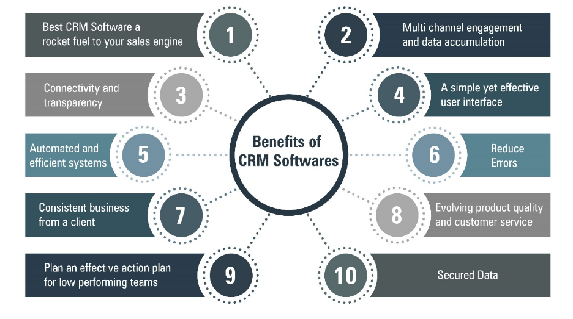
Fig 2.1 Benefits of Medicine Inventory Management Software (Source: Vaidya, 2020)
In small pharmacies and clinics, because of limited resources and fewer staff, it is essential to have an efficient inventory system that minimises manual work and prevents stockouts. Studies show that pharmacies using automated IMS reduce medicine wastage by up to 30% and improve stock availability by over 20%.
A healthcare facility with more than 10 staff members that has adopted an IMS has seen significant improvements in patient satisfaction and operational efficiency. The adoption of IMS has become critical in post-pandemic healthcare environments.

2.5 CASE STUDY OF POPULAR OPERATIONAL INVENTORY MANAGEMENT SYSTEMS
This case study is performed from a functional point of view of different inventory management and pharmacy systems used most by healthcare organizations worldwide.

2.5.1 Meditech Inventory Management
Meditech is a comprehensive healthcare information system used by hospitals globally. Its inventory module integrates with supply chain, procurement, and clinical modules. It is one of the most trusted platforms for large hospital inventory management.
Key points of Meditech Inventory Management:
- Meditech provides real-time tracking of pharmaceutical supplies and medical devices across departments. It is widely used in medium-to-large hospitals for its deep integration with clinical workflows.
- The portal provides end-to-end tracking of all inventory movements, from procurement to dispensing. It supports automated reorder triggers based on minimum stock thresholds.
- The dashboard shows current stock levels, pending purchase orders, and expiry alerts for the day.
- It also offers department-level inventory views and consumption reports in separate sections for day-to-day operations.
- The medication dispensing module integrates with patient prescription records, ensuring accurate dispensing and reducing medication errors.
- It maintains a complete audit trail of all inventory movements, which is critical for regulatory compliance and hospital accreditation.
- The employee can manage the every day business tasks easily with the CRM tool and can also contact customers to give better support before and after sale service.
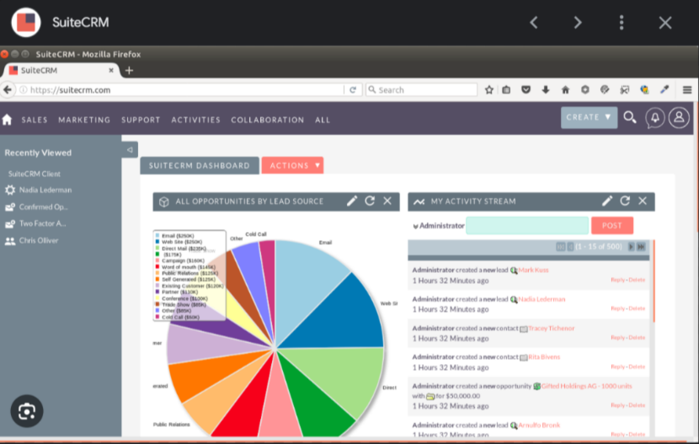
Fig 2.2 Screenshot of Meditech Inventory Management

2.5.2 Oracle Health Inventory Management
Oracle Health (formerly Cerner) provides a cloud-based inventory management module integrated with its comprehensive EHR platform. It is highly scalable and customizable, suitable for large hospital networks and integrated health systems.
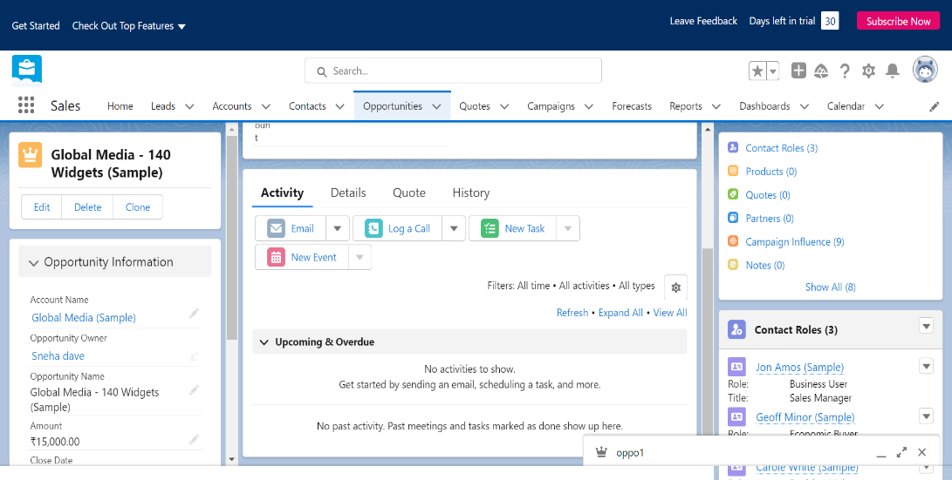
Fig 2.3 Screenshot of Oracle Health Inventory Management
Being enterprise-grade and data-driven, Oracle Health's inventory module has advanced analytics and demand forecasting as its highlights.
- Being user friendly and built on modern cloud infrastructure, Oracle Health's inventory system has analytics and demand forecasting tools as its highlights.
- Stock management is divided into three categories: procurement management, dispensing management, and returns management. The procurement module handles supplier relationships and purchase orders.
- The dashboard displays real-time inventory data with visual charts to evaluate current stock levels and upcoming expiry dates.
- Oracle Health effectively manages medicine categories with organized sections like controlled substances, OTC medications, vaccines, and surgical supplies.
- Data is freely accessible to authorized personnel from any location because of the cloud-based infrastructure.
- The collaboration module allows pharmacists, procurement teams, and department heads to coordinate on purchase orders and stock transfers.
- Oracle Health has significantly reduced the need for manual stock-counting in large hospitals, offering automated cycle count workflows, barcode scanning support, and RFID integration.

2.5.3 OpenMRS / GNU Health
OpenMRS is an open-source health record and inventory management platform that creates a customizable solution for healthcare providers to track their medicine supplies. It is widely used in developing countries and resource-limited settings.
OpenMRS displays stock analysis on its dashboard to help administrators make better procurement decisions.
Stock tracking, dispensing records, supplier management, and basic analytics are the major highlights attracting NGOs and public health organizations to use OpenMRS.
For monitoring and managing medicine distribution, it offers stock adjustment and drug dispensing modules.
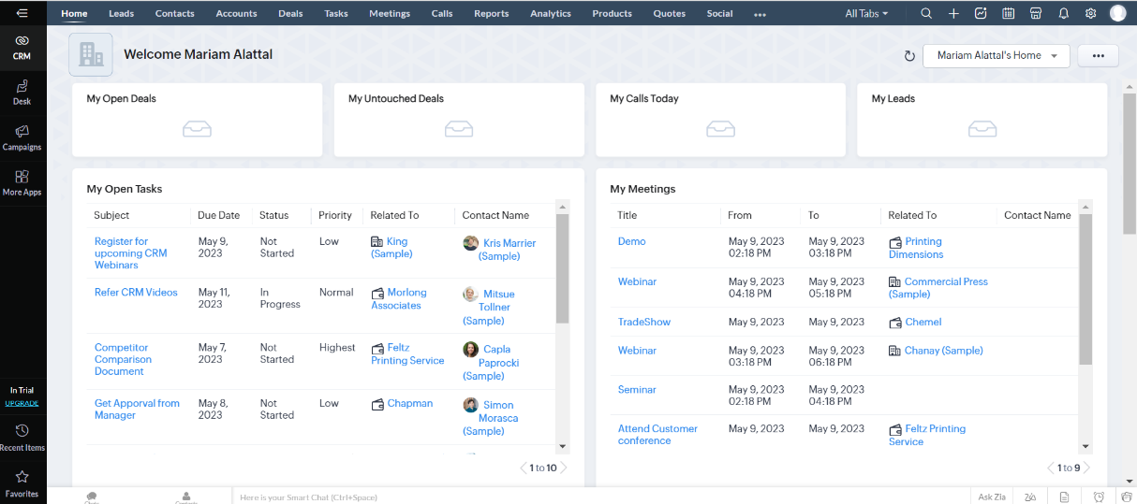
Fig 2.4 OpenMRS Inventory Dashboard
The stock forecasting option allows administrators to set reorder points, track consumption trends, and analyse results to improve procurement planning.
Advanced reporting offered by OpenMRS supports in-depth insights about medicine consumption patterns and budget allocations.

2.5.4 Infor CloudSuite Healthcare
Infor CloudSuite Healthcare is one of the leading supply chain management solutions trusted and used by over 3000 healthcare organizations globally. It specializes in medical supply and pharmaceutical inventory management with end-to-end visibility.
The solution is integrated with several third-party tools including barcode scanners, EHR platforms, and procurement portals.
- The user dashboard is clear and focused, letting you manage inventory tasks without cluttered screens and unnecessary data overload.
- Set up team roles with different access permissions depending on designation and work requirements.
- It helps to set visibility for medicines, purchase orders, and supplier data to staff members according to their roles and responsibilities.
- It allows sending reports as CSV or PDF files and can send them as documents to other departments or directly to procurement managers.
- It tracks stock levels and lets you customize automatic reorder triggers, focusing on the specific procurement requirements of the healthcare facility.
- A project management module is integrated into the system that helps in easy tracking of procurement project status and can be updated based on delivery milestones.
- Can manage supplier relationships better with timely purchase orders and delivery tracking.
- Scheduling purchase orders with supplier details, delivery windows, and contact information helps to maintain seamless supply chains.
- Analytics of current inventory position across departments in a single dashboard screen provides critical data for supply chain managers.
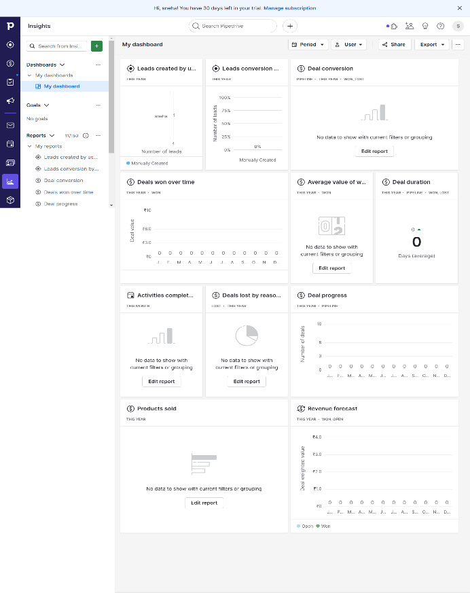
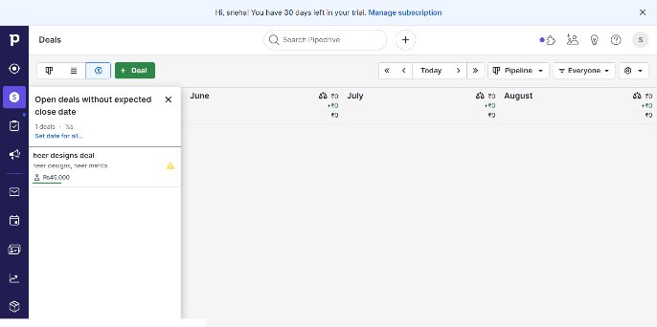
Fig 2.5 Screenshot of Infor CloudSuite Healthcare Dashboard

2.5.5 Marg ERP (Pharmacy)
Marg ERP provides detailed insights into the different modules of a pharmacy management system. The reports generated are separately focused on sales, purchases, expiry management, and GST compliance.
- Visualize data as a table, list, or summary dashboard, and access quick actions to perform stock adjustments and purchase entries at scale.
- The system offers a 360° view of pharmacy operations across purchase, sales, and stock management with customizable product categories and batch tracking.
- It facilitates engagement across channels — physical counter sales, wholesale distribution, and online pharmacy portals.
- It helps improve procurement decisions with automated reorder alerts based on minimum stock levels, which is an intelligent feature built into the core workflow.
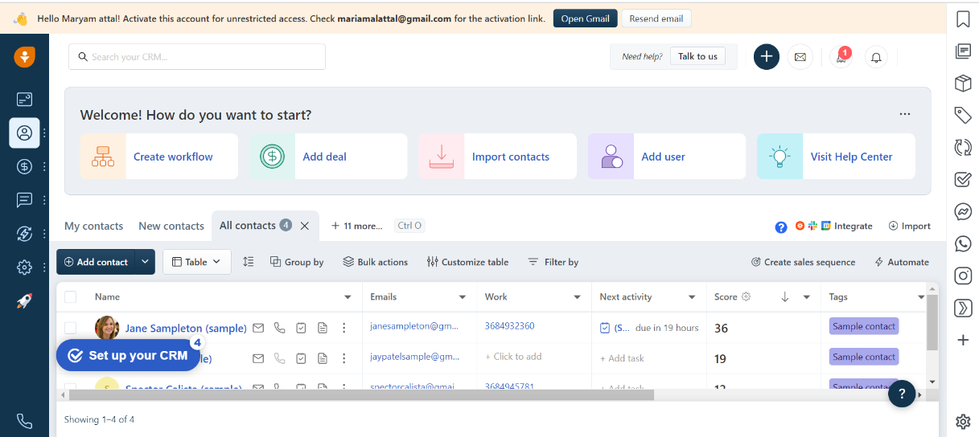
Fig 2.6 Screenshot of Marg ERP Pharmacy

2.5.6 PharmAssist / MedEase
PharmAssist (and similar systems like MedEase) are specialized inventory management software for small to medium-sized pharmacies. They help to keep pharmacy operations in flow and give real-time visibility into stock and sales.
Decision-making processes for future medicine procurement largely depend on analysis of current and past consumption data effectively. These systems provide daily sales summaries and weekly expiry reports.
- PharmAssist shows major pharmacy operations on the dashboard including latest medicines added, upcoming expiry alerts, and low-stock notifications.
- It has an integrated billing module that supports generating purchase invoices and supplier payment tracking. It has separate sections to track GST-compliant invoicing.
- The same login credentials can be used on a mobile app which helps pharmacists stay updated about stock movements even when away from the counter.
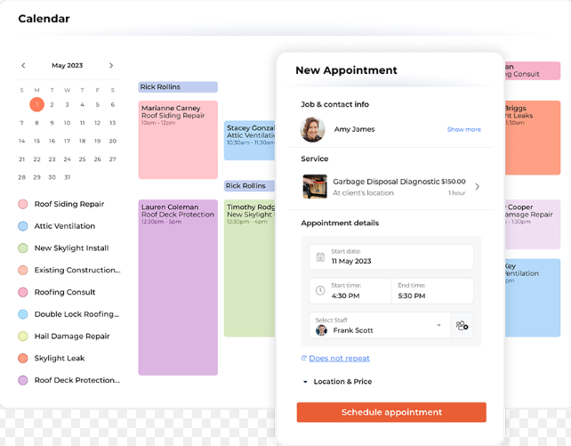
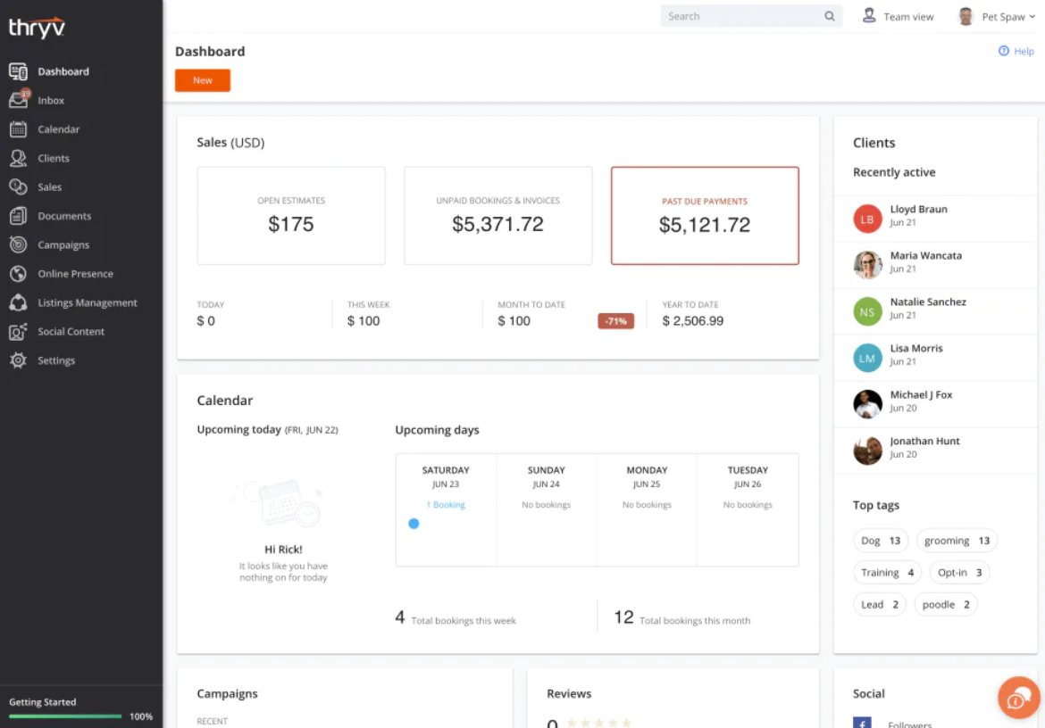
Fig 2.7 Screenshot of PharmAssist Dashboard

2.5.7 MedTrack Pro
It is one of the most used inventory management platforms across pharmacy chains and hospital supply departments. The system provides a comprehensive view of all medicine movements with role-based access for pharmacists, managers, and administrators.
- It lets you build a personalized dashboard by selecting necessary KPI indicators for your specific healthcare operation.
- The customizable screen is provided for stock monitoring, procurement management, expiry management, and automated reorder management.
- It tracks the consumption rate of each medicine over time to warn you when demand is increasing and stock levels need immediate replenishment.
- It has integration with supplier email notifications along with SMS alerts, barcode scanners, and automated purchase order forms.
- Procurement module allows managing suppliers, purchase orders, delivery tracking, and invoice matching with available integrated workflows.
- Reports focus on expiry-wise stock, batch-wise tracking, category-wise consumption, and forecasted demand, which is a key analytical feature for inventory optimization.
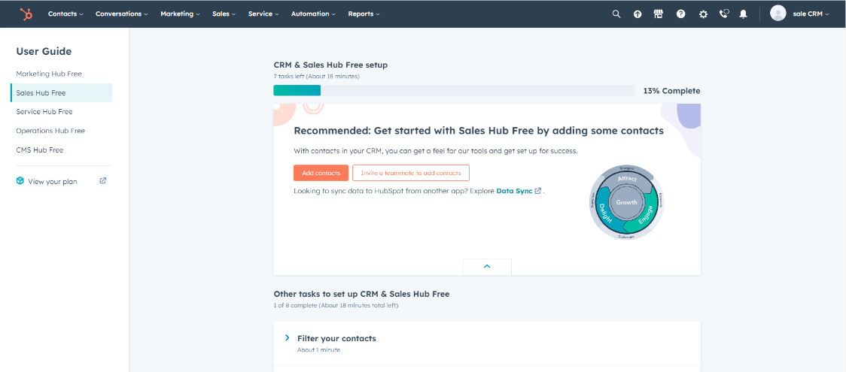
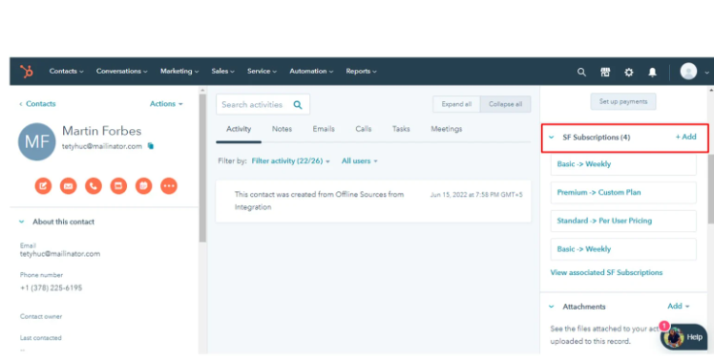
Fig 2.8 Screenshot of MedTrack Pro
Chapter 3
Project Management
3.1 Project Planning Objectives
3.2 Project Scheduling
3.3 Risk Management
Chapter 3

PROJECT MANAGEMENT

3.1 PROJECT PLANNING OBJECTIVES
The project planning phase of MediStock defined the scope, the resources, the development approach and the schedule before coding started. Tasks such as feature specification, technology selection and workflow structuring were completed first, so that development could then proceed module by module with clear deliverables and milestones.

3.1.1 Software Scope
The software scope of MediStock covers the complete stock-to-report cycle of a pharmacy or hospital dispensary. Users sign in with role-based access, add and maintain medicines with batch and expiry details, manage categories and suppliers, raise and receive purchase orders, view forecasts and alerts on the dashboard, import and export data in CSV/XLSX format, generate PDF and XLSX reports and review audit logs. Administrators additionally manage users and system settings. Barcode scanning, mobile applications and integration with hospital systems are not part of this release.

3.1.2 Resources
The resources needed for the project are grouped into human resources, reusable software resources and environment resources.

3.1.2.1 Human Resource
The project was carried out by one developer-intern, Yug Patel, who handled analysis, design, front-end, back-end, database and testing work under the guidance of the internal guide, Ms Sweta Rathod, Department of Computer Science & Engineering, IITE, Indus University. Mentors and colleagues at the host organisation supported the work through discussions, code reviews and feedback. Pharmacists, inventory managers and administrators are the intended end users whose workflows the system follows.

3.1.2.2 Reusable Software Resource
MediStock reuses well-tested open-source components instead of building them from scratch: React components for the interface, Bootstrap for the responsive layout, Chart.js for charts, Axios for API calls, Express for routing and request handling, Mongoose for schema definition and validation, JWT for authentication, jsPDF for PDF reports and SheetJS (XLSX) for spreadsheet import and export. Reuse shortened development time and reduced defects, and these libraries are widely documented and regularly updated.

3.1.2.3 Environment Resource
Development and testing were carried out on a Windows machine with Node.js, a MongoDB database, a code editor and the Google Chrome, Microsoft Edge and Mozilla Firefox browsers. Postman was used to check API endpoints and status codes, and the project source code is maintained in a GitHub repository for version control. Sample medicines, categories, suppliers and purchase orders were loaded through the CSV/XLSX import feature to provide realistic test data.

3.1.3 Project Development Approach
The development of MediStock follows the Software Development Life Cycle (SDLC) so that the work stays structured and every phase produces a checked result. The requirement phase gathers the needs of pharmacists, managers and administrators, which are then turned into a design of modules, database collections and UML diagrams. The development phase codes the front end, the REST API and the database layer according to that design. The testing phase, which follows the Software Testing Life Cycle (STLC), finds and removes defects, and deployment and maintenance keep the system usable and up to date.
- Requirement Gathering and Planning
- Analysis and Design
- Implementation or Coding
- Testing and Integration
- Deployment and Maintenance
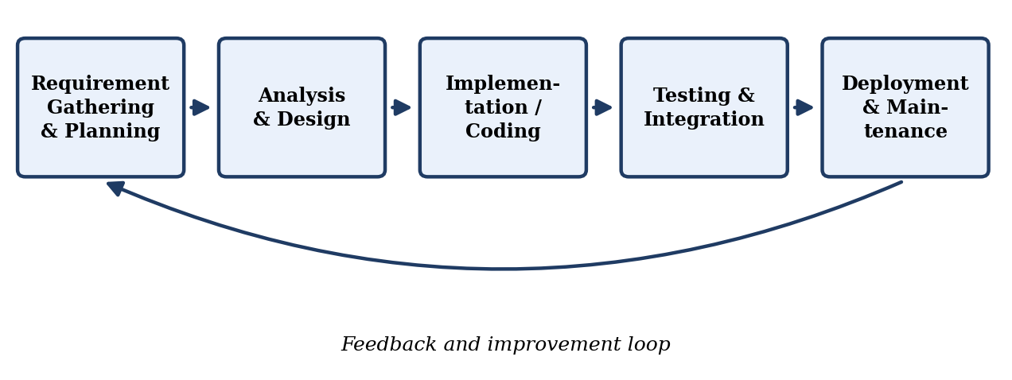
Fig 3.1.3.1 SDLC

3.2 PROJECT SCHEDULING
Project scheduling for MediStock arranges the activities and milestones needed to complete the project in the available time. It ensures that resources are used well, that tasks are executed in a sensible order and that each stage, from case study to documentation, is finished before the next one depends on it.

3.2.1 Basic Principle Scope
The basic principles behind the schedule are task identification, estimation of effort, sequencing of tasks, allocation of resources, definition of milestones and regular monitoring of progress. Applying them to MediStock meant identifying the modules to be built, estimating the effort for the front end, back end and testing, and ordering the work so that authentication and medicine management were ready before purchase orders, forecasting and reports were added.

3.2.2 Compartmentalization Scope
MediStock is divided into independent modules: authentication and users, medicines, categories, suppliers, purchase orders, inventory movements, forecasts, reports, audit logs and settings. Each module has its own collection in the database, its own API routes and its own screens. This allows one module to be changed or tested without disturbing the others, keeps business logic separate from the user interface and limits data access to the modules that need it.

3.2.3 Work Breakdown Structure
The Work Breakdown Structure (WBS) divides the project into seven phases, each broken into smaller work packages that can be assigned, tracked and reviewed. Table 3.2.3.1 lists the phases and their work packages.
Table 3.2.3.1 Work Breakdown Structure
Phase | Name | Work Packages
1 | Case Study | Requirement gathering; requirement analysis
2 | Feasibility Study | Economic, technical and operational feasibility
3 | Design | UML diagrams; database design; validation requirements; input and output of every module
4 | Front-End Design and Coding | Creating forms; adding validation
5 | Back-End Development | Setting up modules and the programming paradigm; calling APIs and adding code
6 | Testing | Testing with functionality; checking bugs; resolving bugs; listing output
7 | Documentation | Adding documentation; preparing the presentation

3.2.4 Project Organization
The project was organised around one developer-intern who was responsible for every work package, an internal guide who reviewed the work and approved each stage, and mentors at the host organisation who gave technical feedback. Progress was discussed in regular meetings and progress evaluations, and issues found in reviews were recorded and resolved before the next phase started. This structure gave clear accountability and short feedback cycles.

3.2.5 Timeline Chart
The timeline chart shows when each phase of the project was planned to start and finish and how much time was allocated to each activity.

3.2.5.1 Time Allocation Chart
The Gantt chart in Fig 3.2.5.1 shows the seven phases of the project along a time axis. The back-end development phase receives the largest share of the time, followed by front-end coding, design and documentation, while the case study, feasibility study and testing phases are shorter.
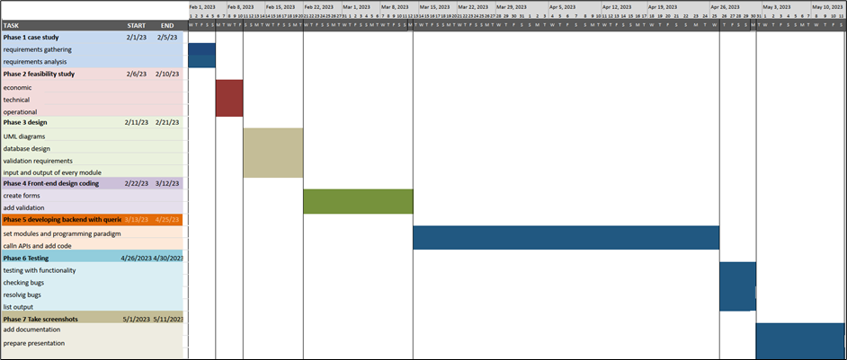
Fig 3.2.5.1 Time Allocation Chart (Gantt Chart)

3.2.5.2 Task Sets
Table 3.2.5.1 groups the work into task sets, with the deliverable expected from each set and the approximate time allocated to it. The total duration is about fourteen to fifteen weeks.
Table 3.2.5.1 Task Sets
Phase | Task Set | Deliverable | Duration
1 | Case study of existing systems and requirements | Requirement list | 1 week
2 | Economic, technical and operational feasibility | Feasibility findings | 1 week
3 | UML diagrams and database design | Design diagrams, collection schemas, validation rules | 1.5 weeks
4 | Front-end forms and validation | React screens for all modules | 2.5 weeks
5 | Back-end modules, APIs and integration | Working REST API connected to MongoDB | 6 weeks
6 | Functional and non-functional testing | Test results and fixed defects | 1 week
7 | Documentation and presentation | Project report and presentation | 1.5 weeks

3.3 RISK MANAGEMENT
Risk management for MediStock means identifying, assessing and reducing the events that could affect the quality or the delivery of the project. By dealing with technical, security, schedule and data risks early, the project avoids disruptions and keeps the system reliable.

3.3.1 Risk Identification
Risks were identified by reviewing the requirements, studying similar inventory systems, discussing possible problems with the guide and mentors, and considering the technology stack. The main areas examined were data safety, unauthorised access, accuracy of forecasts, integration problems, limited availability of real pharmacy data, and changes in scope.

3.3.1.1 Risk Identification Artifacts
The identified risks are documented in a risk register that records the description, category, probability, impact and planned mitigation of each risk. The register, together with the issue list kept during testing, served as the artifact for tracking risks throughout the project.

3.3.2 Risk Projection
Risk projection rates every identified risk by its probability and its impact so that attention goes to the most serious ones first. Table 3.3.2.1 shows the risk register of MediStock with the mitigation adopted for each risk.
Table 3.3.2.1 Risk Projection
Risk | Category | Probability | Impact | Mitigation
Loss or corruption of stored data | Technical | Low | High | Regular backups and schema validation through Mongoose
Unauthorised access to stock and procurement data | Security | Medium | High | JWT authentication, hashed passwords and role-based route checks
Inaccurate forecasts because of poor consumption data | Technical | Medium | Medium | Input validation, import checks and use of clean sample data
Integration problems with reporting and email features | Schedule | Medium | Medium | Incremental development and early integration testing
Growth of scope during development | Project | Medium | Medium | Fixed module list; new ideas moved to future enhancements
Browser or screen-size incompatibility | Technical | Low | Medium | Testing on Chrome, Edge and Firefox and a responsive layout
Limited availability of real pharmacy data | Resource | High | Medium | Sample data loaded through the CSV/XLSX import feature

Chapter 4
System Requirements
4.1 User Characteristics
4.2 Functional Requirement
4.3 Non-Functional Requirement
4.4 Hardware and Software Requirement
Chapter 4

SYSTEM REQUIREMENTS

4.1 USER CHARACTERISTICS
The users of MediStock differ in their roles, technical skill and the parts of the system they need. Pharmacists and dispensary staff use it every day to look up stock and update quantities, so they need a simple and fast interface. Managers and procurement officers work with suppliers, purchase orders and reports. Administrators manage users, settings and audit logs, and auditors read the records. Most of them are not technical, so the system must be easy to learn and must use plain, clearly labelled forms and menus.

4.1.1 Target Audience
The target audience for the MediStock : Medicine Stock Intelligence system encompasses a diverse range of stakeholders within the healthcare industry. Here are the primary groups that would benefit from the system:
1. Pharmacists and Dispensary Staff
- Retail Pharmacists: Staff who manage day-to-day medicine dispensing and need a comprehensive system to track stock levels, expiry dates, and batch numbers.
- Hospital Dispensary Staff: Staff working in hospital pharmacies who require robust tools to manage high-volume medicine stock movements and inter-department transfers.
2. Healthcare Facilities
- Small to Medium Clinics and Pharmacies: Facilities that manage a moderate number of medicine categories, looking for an affordable yet powerful inventory management solution.
- Large Hospitals: Hospitals with extensive medicine requirements across multiple departments, requiring advanced features, scalability, and multi-role access control.
3. Medical Distributors and Suppliers
- Medicine Distributors: Organizations that distribute medicines to multiple pharmacies and need an efficient way to track delivery schedules and inventory levels at client facilities.
- Procurement Officers: Departments within healthcare facilities responsible for managing and updating supplier contacts, purchase orders, and receiving deliveries.
4. Healthcare Clients
- Individual Patients: Customers purchasing prescription medicines who benefit from streamlined dispensing workflows and efficient stock availability management.
- Corporate Healthcare Clients: Organizations seeking comprehensive medicine supply for their operational health programs, requiring seamless management and accurate reporting.
5. Business Managers and Administrators
- Operations Managers: Professionals overseeing the operational aspects of pharmacy chains or hospital supply departments, needing detailed reports and real-time inventory dashboards.
- IT Administrators: Technical staff responsible for managing the system, ensuring data security, and integrating with hospital management systems.
6. Regulatory Bodies
- Compliance Officers: Individuals ensuring that pharmacies and healthcare facilities adhere to drug regulatory standards and maintain accurate controlled substance records.
- Auditors: Professionals conducting audits and assessments of medicine procurement practices, requiring detailed audit logs and transparent records.

4.1.2 Target Audience Needs
The MediStock : Medicine Stock Intelligence system is designed to meet the specific needs of these diverse groups by providing:
- Efficiency: Streamlined processes for managing stock, suppliers, purchase orders, and consumption tracking.
- User-Friendliness: Intuitive interface and easy-to-learn system for quick adoption by non-technical healthcare staff.
- Scalability: Capability to grow with the facility, accommodating increasing medicine categories and user numbers.
- Security: Robust JWT-based authentication and role-based access control to ensure medicine and procurement data is secure.
- Comprehensive Features: A wide range of functionalities covering all aspects of medicine inventory management including forecasting, alerts, and reporting.
- Customization: Ability to tailor the system to specific healthcare workflows, including custom alert thresholds and report templates.
By targeting these audiences, the MediStock : Medicine Stock Intelligence system aims to become an essential tool for improving procurement efficiency, ensuring medicine availability, and reducing wastage across healthcare organizations.

4.2 FUNCTIONAL REQUIREMENT
Functional requirements describe what MediStock must do to meet the needs of its users. The main functional requirements are listed below.
- User Authentication and Roles: Registration with email verification, secure login, password reset and role-based access for Admin, Manager, Pharmacist and Cashier users.
- Medicine Management: Add, edit, search, filter and delete medicines with batch number, expiry date, supplier, category and quantity.
- Automatic Stock Status: Assign In Stock, Low Stock, Out of Stock and Expiring Soon status automatically from quantity, reorder level and expiry date.
- Supplier and Category Management: Add, update and deactivate suppliers, and maintain medicine categories.
- Purchase Orders: Create purchase orders linked to a medicine and a supplier, track their status and update stock when delivery is confirmed.
- Demand Forecasting: Forecast demand from average monthly consumption, safety stock and lead time, and compute a shortage risk score.
- Alerts and Dashboard: Show stock metrics, charts, low-stock alerts and expiry warnings on the dashboard.
- Import, Export and Reports: Import medicine data from CSV/XLSX files and generate PDF and XLSX reports.
- Audit Logs and Administration: Record user activity with time stamps and allow the administrator to manage users and system settings.

4.2.1 Activity and Proposed System
MediStock is developed through a structured set of activities. Requirement analysis identifies the needs of the users, and project planning decides the architecture, technologies and timeline. In system design, the interface, the database collections and the UML diagrams are prepared. The development phase implements authentication, medicine and inventory management, purchase orders, forecasting, reports and audit logs, and testing and integration check that these features work together. Each activity improves the reliability and usability of the proposed system.

4.3 NON-FUNCTIONAL REQUIREMENT
Non-functional requirements describe the qualities and constraints that the system must satisfy in addition to its functions. For MediStock they are:
- Performance: Pages, tables and charts should load without noticeable delay for normal data volumes.
- Security and Privacy: Passwords must be stored in hashed form, every protected route must check the JWT and the user role, and expired or tampered tokens must be rejected.
- Data Integrity: Stock quantities, statuses and purchase-order records must stay consistent across all screens and match the movement history.
- Usability: Common tasks such as adding a medicine, raising a purchase order or downloading a report should be completed by a new user without assistance.
- Compatibility: The web application must work in current versions of Google Chrome, Microsoft Edge and Mozilla Firefox and on desktop, tablet and mobile screen widths.
- Reliability: Repeated create, update and delete operations must not cause data loss or unexpected errors.
- Scalability and Maintainability: The modular structure and the MongoDB database should allow more users, medicines and modules to be added without redesigning the system.

4.4 HARDWARE AND SOFTWARE REQUIREMENT
To deploy the application, the only technical aspects needed are mentioned below:

4.4.1 Hardware Requirement
- A machine with proper connectivity to the internet, a mouse, a keyboard, a display unit, and a processing unit.
- RAM: 4GB or more
- HDD: 20GB or more

4.4.2 Software Requirement
- Platform: Windows, Linux, Mac
- Programming language: JavaScript (Node.js / React)
- Database: MongoDB
- Front-End: React with Vite, Bootstrap and Chart.js for the user interface.
- Back-End: Node.js with Express for the REST API, with JWT for authentication.
- Browser: Google Chrome, Microsoft Edge or Mozilla Firefox (latest versions).
- Tools: A code editor, Postman for API testing and Git/GitHub for version control.

4.4.3 Server Hosting Requirement
To make MediStock available to users of a pharmacy or hospital, the hosting environment should meet the following requirements:
- Operating System Support: A Windows or Linux server that can run Node.js.
- Database Support: A MongoDB instance, either self-hosted or cloud-hosted, reachable by the API server.
- Storage Capacity: Enough storage for the database, generated reports and regular backups.
- Security Features: HTTPS (SSL/TLS) encryption, a firewall and protected environment settings for secrets such as the JWT key.
- Performance and Availability: Reliable uptime and sufficient memory and processing capacity for the expected number of concurrent users.
- Scalability: Ability to upgrade resources as the number of users and medicine records grows.
Chapter 5
System Analysis
5.1 Study of Current System
5.2 Problems in Current System
5.3 Requirement of New System
5.4 Process Model
5.5 Feasibility Study
5.6 Features of New System
Chapter 5

SYSTEM ANALYSIS

5.1 STUDY OF CURRENT SYSTEM
In most small and medium pharmacies and clinics, medicine stock is still kept in paper registers, billing software that shows only current quantities, or spreadsheets maintained by different people. Expiry dates are checked by walking through the shelves, reorder decisions depend on the memory and experience of the staff, and purchase orders are prepared separately from the stock records. Large hospitals use enterprise suites, but these are costly and complex, and are studied in Chapter 2.
Because the records are scattered, it is hard to know the true stock at any moment, to link a delivery with the order that caused it, or to find out who changed a record. There is also no systematic use of past consumption to plan future purchases.

5.1.1 Importance of Inventory Management in Healthcare
Inventory Management isn't just a logistical solution for large hospitals. It helps create stronger supply chains for pharmacies of all sizes. For small clinics, having the right medicine at the right time directly impacts patient outcomes. Effective inventory management reduces medicine wastage by up to 30% and improves stock availability significantly.
A common problem with inventory systems is that they can become clogged with outdated or irrelevant stock data over time. Regular system audits and automated data validation features in the MediStock : Medicine Stock Intelligence system help resolve these issues efficiently.

5.1.2 IMS Implementation Challenges
The problem with IMS implementation can be resolved by introducing the new system comprehensively, ensuring all staff are trained, processes are clearly documented, and data migration from legacy systems is handled carefully.

5.1.3 Popular IMS Platforms
Popular inventory management platforms like Meditech, Oracle Health, and Infor CloudSuite offer comprehensive supply chain management, stock tracking, demand forecasting, and regulatory compliance tools — but at high costs suitable only for large organizations.

5.2 PROBLEMS IN CURRENT SYSTEM
The healthcare and pharmacy industry faces challenges in real-time tracking of medicine inventory, managing expiry dates, predicting demand fluctuations, segmentation of medicine categories, and generating timely procurement reports. Manual processes are error-prone and lead to overstocking, wastage, and critical shortages that can endanger patient health.
In detail, the current practice suffers from delayed detection of low stock and expiring medicines, over-stocking that ends in expired stock, duplicate and inconsistent records, no link between purchase orders and stock movements, little or no audit trail, and reports that take a long time to prepare manually. Access to records is usually not restricted by role, which also creates security and accountability problems.

5.3 REQUIREMENT OF NEW SYSTEM
The new system must overcome these problems by keeping all stock, supplier and order data in one place and by acting on that data. It must show real-time stock and automatic status for every medicine, warn about low stock and near-expiry medicines, forecast demand and rank medicines by shortage risk, link purchase orders with stock movements, keep an audit log, restrict access by role, and produce reports and exports on demand. It must also be affordable, easy to learn and able to grow with the facility.
Analysis Process: After carefully analyzing the requirements and the functionality of existing inventory management platforms like Meditech, Oracle Health, Marg ERP, and MedTrack Pro, the system design was finalized.

5.4 PROCESS MODEL
For MediStock the Incremental Model is the most suitable development approach. The system is built and released in stages, so that the essential functions are available and tested first and further functions are added in later increments. The first increment delivers authentication, roles and medicine and category management. The second adds suppliers, purchase orders and stock movements, the third adds demand forecasting, alerts and dashboard charts, and the fourth adds reports, CSV/XLSX import and export and audit logs.
This step-by-step approach keeps the system usable at every stage and allows feedback from mentors and the guide to be included in the next increment. It also reduces risk, because each increment is tested before the next one depends on it.
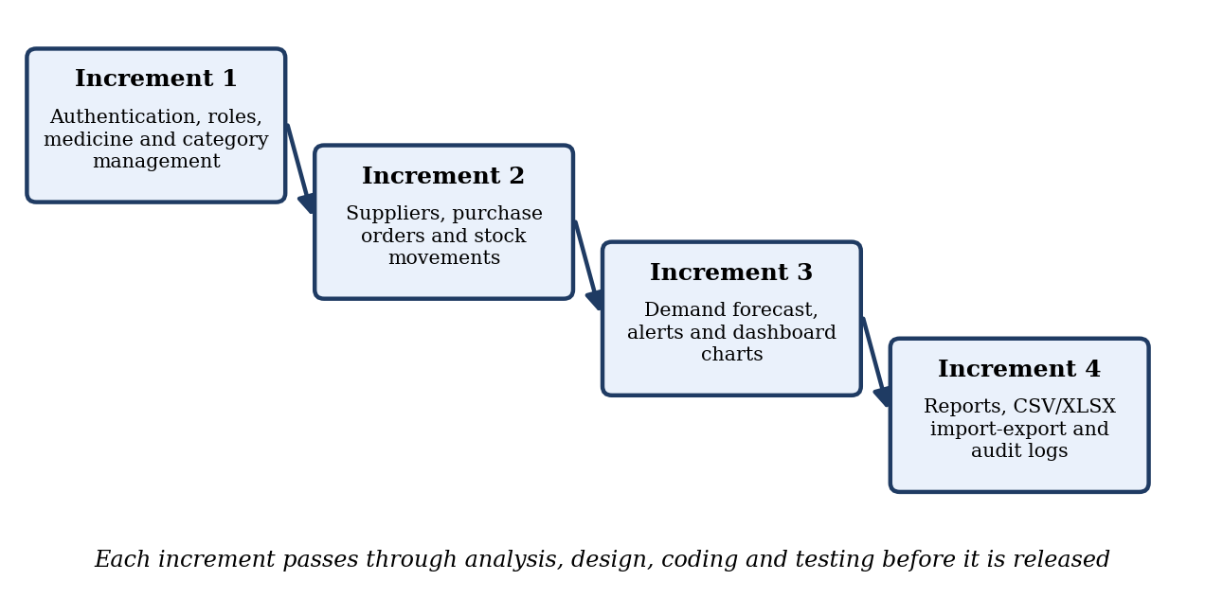
Fig 5.4.1 Incremental Model

5.5 FEASIBILITY STUDY
The feasibility study for MediStock : Medicine Stock Intelligence was performed to understand the feasibility of implementing this new system, ensuring it is technically, economically, and legally viable for deployment in real healthcare environments.

5.5.1 Technical Feasibility
Technical feasibility checks whether the system can be built with the available technology. MediStock uses mature and widely supported technologies: React and Vite for the interface, Node.js and Express for the API, MongoDB with Mongoose for storage, and Chart.js, jsPDF and SheetJS for charts, PDF reports and spreadsheets. All of them run on ordinary computers, so the system is technically feasible. The hardware and software needed for deployment are listed in Chapter 4.

5.5.2 Operational Feasibility
- Purpose: The purpose of this system is to achieve better management and efficiency in handling medicine inventory, supplier relationships, purchase orders, and stock forecasting for healthcare facilities.
- Modules: The process involves two important modules:
  - Pharmacist / Inventory Manager: Manages and updates medicine stock, expiry dates, purchase orders, and supplier details.
  - Administrator: Maintains and updates user accounts, system configurations, and generates audit reports.
- System Features: The system helps inventory managers to manage their everyday tasks including stock monitoring, purchase order creation, expiry alerts, and report generation.

5.5.3 Economic Feasibility
Economic feasibility compares the cost of the system with its benefits. The development stack has no licence cost, only a normal computer and internet connection are needed to develop and run the system, and hosting can start on a modest server. The benefits are less wastage from expired stock, fewer shortages, and staff time saved on manual counting and report preparation, so the project is economically feasible.

5.5.4 Schedule Feasibility
Schedule feasibility checks whether the project can be finished in the available time. The work was divided into seven phases with a total duration of about fourteen to fifteen weeks, as shown in the Gantt chart in Chapter 3. The incremental approach, regular reviews with the guide and the reuse of open-source libraries made it possible to complete the planned modules within this schedule.

5.5.5 Legal Feasibility
- Prototype Nature: As the system is prepared for demonstration of a system that can be used to manage healthcare inventory operations more efficiently, it does not handle real patient data and is compliant with basic data protection principles.
- Open Source Software: The software stack used to develop the system (React, Node.js, MongoDB, Chart.js) is entirely open-source and free to use.

5.6 FEATURES OF NEW SYSTEM
The MediStock : Medicine Stock Intelligence system should be capable of managing and displaying medicine stock levels, expiry alerts, and supplier data efficiently. It should support demand forecasting using average monthly consumption, shortage risk scoring, purchase order management, and comprehensive PDF/XLSX reporting.
- Secure Access: Email-verified registration, JWT login and role-based permissions for Admin, Manager, Pharmacist and Cashier.
- Real-Time Inventory: Medicine records with batch, expiry and quantity, and automatic In Stock, Low Stock, Out of Stock and Expiring Soon status.
- Procurement: Supplier records and purchase orders that update stock and movement history on delivery.
- Prediction: Demand forecast from average monthly consumption, safety stock and lead time, with a shortage risk score.
- Alerts and Dashboard: Live stock metrics, charts, low-stock alerts and expiry warnings.
- Data Exchange and Reports: CSV/XLSX import and PDF/XLSX export of inventory, expiry analysis and supplier purchase history.
- Accountability: Audit logs of user activity with time stamps.
Chapter 6
System Design
6.1 Class Diagram
6.2 Use Case Diagram
6.3 Sequence Diagram
6.4 Activity Diagram
6.5 Entity-Relationship Diagram
6.6 Context Diagram
6.7 Data Flow Diagram
6.8 Data Dictionary
Chapter 6

SYSTEM DESIGN

6.1 CLASS DIAGRAM
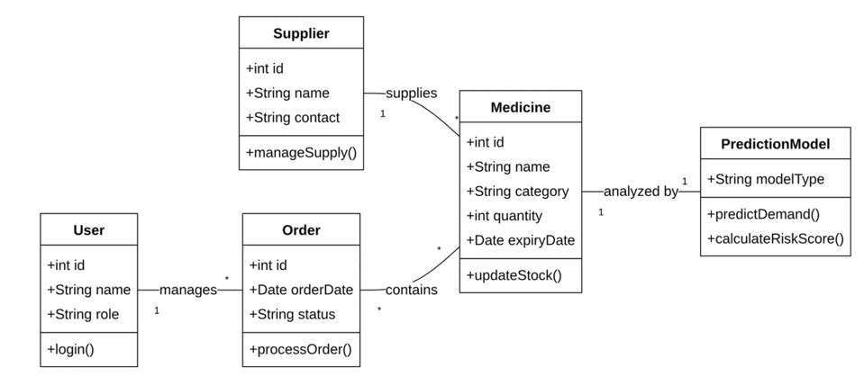
Fig 6.1.1 Class Diagram
The Class Diagram for MediStock represents the structure of the system by defining its key classes such as User, Medicine, Category, Supplier, PurchaseOrder, InventoryMovement, Forecast, Report and AuditLog, along with their attributes, operations and relationships.

6.2 USE CASE DIAGRAM
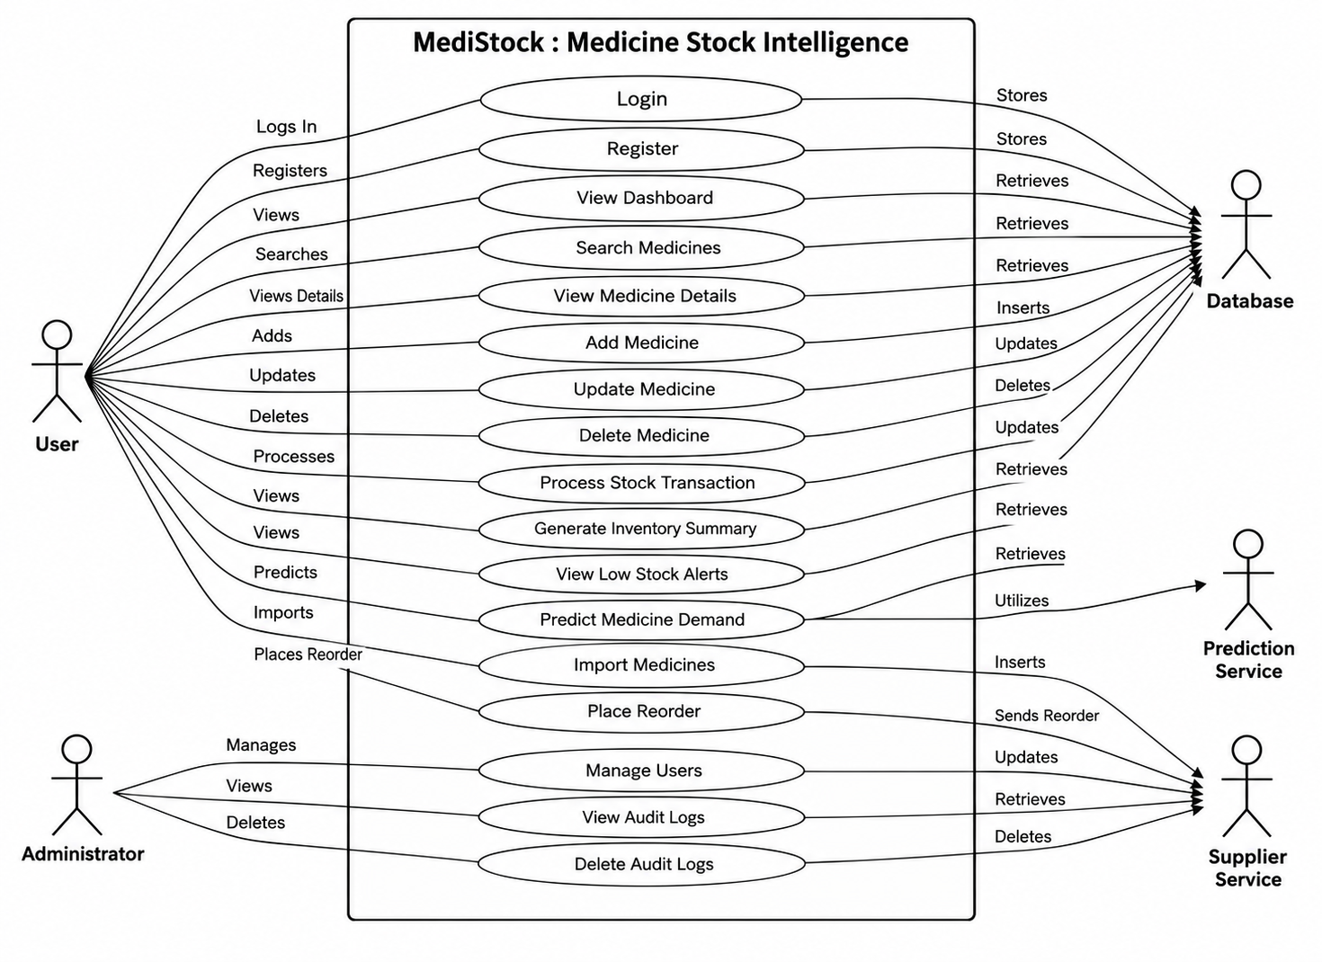
Fig 6.2.1 Admin Use Case Diagram
The Admin use-case diagram shows how the administrator manages users and roles, medicine categories, suppliers and system settings, and reviews audit logs and reports.

6.3 SEQUENCE DIAGRAM
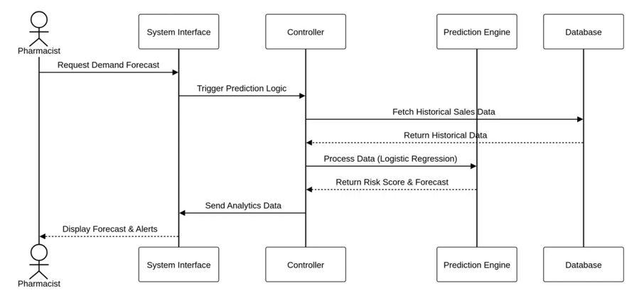
Fig 6.3.1 Sequence Diagram
Sequence diagrams are interaction diagrams that detail how operations are carried out. This diagram captures the interaction between the user, the React frontend, the Express API and the MongoDB database while a medicine is added and its stock status is updated.

6.4 ACTIVITY DIAGRAM
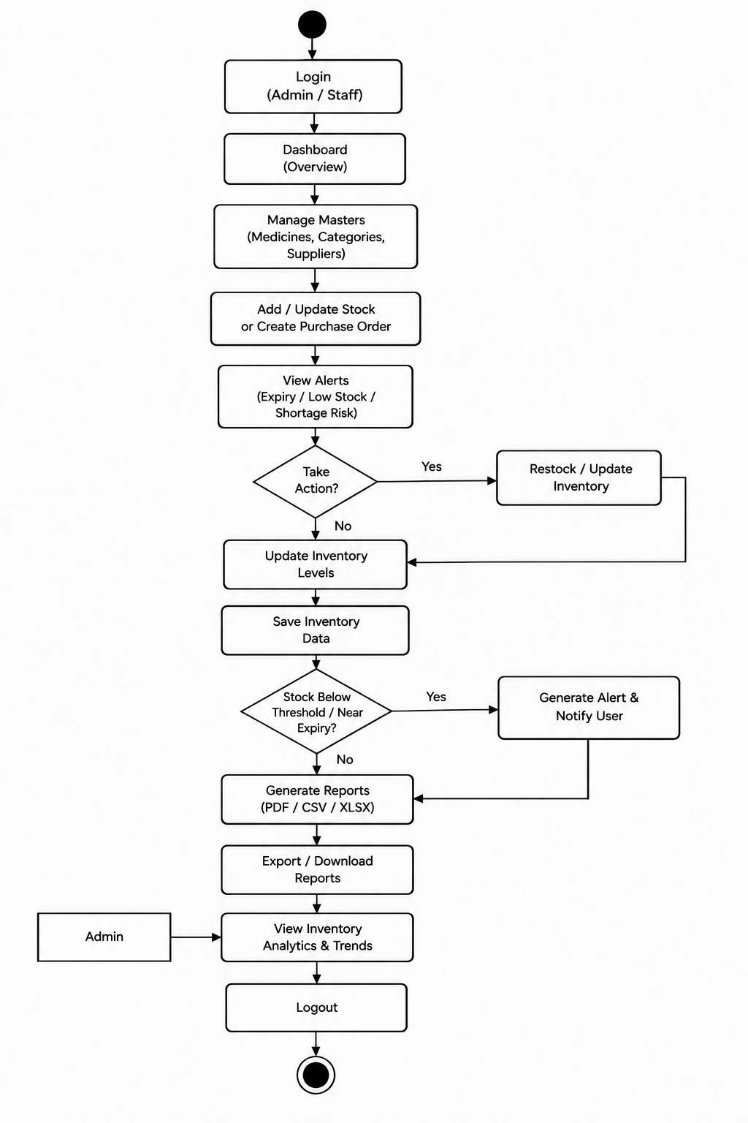
Fig 6.4.1 Activity Diagram
The activity diagram depicts the workflow of the system from login to medicine and inventory management, purchase order creation, alert generation and report download. It outlines process sequences, decisions and parallel tasks.

6.5 ENTITY-RELATIONSHIP DIAGRAM
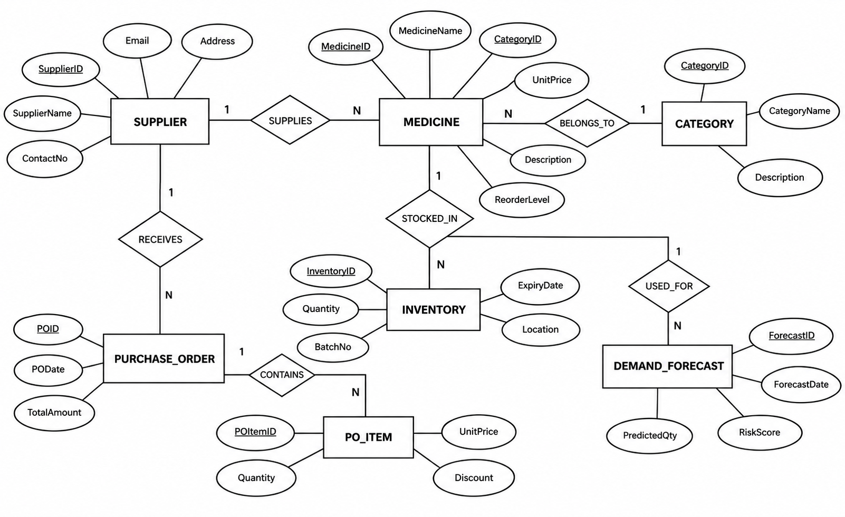
Fig 6.5.1 Entity-Relationship Diagram
The ER Diagram illustrates the relationships between entities such as User, Medicine, Category, Supplier, PurchaseOrder, InventoryMovement and Forecast, ensuring efficient and consistent management of medicine stock.

6.6 CONTEXT DIAGRAM
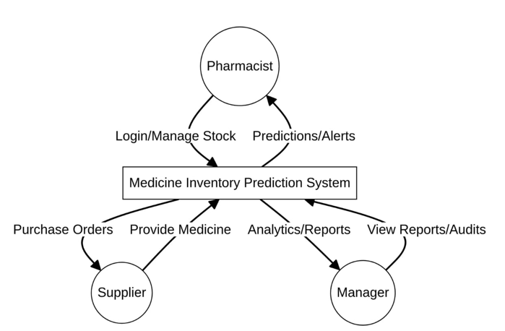
Fig 6.6.1 Context Diagram
The Context Diagram shows the interaction of the system with external entities such as the Administrator, the Pharmacist and the Supplier. It highlights the data flowing between them and the system.

6.7 DATA FLOW DIAGRAM
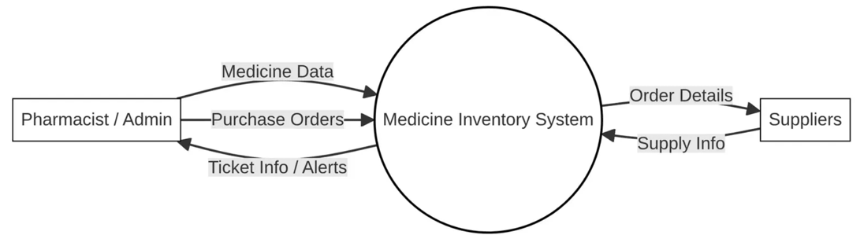
Fig 6.7.1 Data Flow Diagram LEVEL-0
The Level-0 DFD shows the overall flow of data between users, the MediStock : Medicine Stock Intelligence system and its data stores.

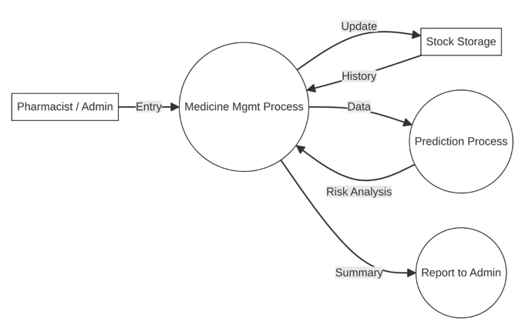
Fig 6.7.2 Data Flow Diagram LEVEL-1
Level-1 DFD shows how users log in and how the admin manages users, categories, suppliers and system settings.
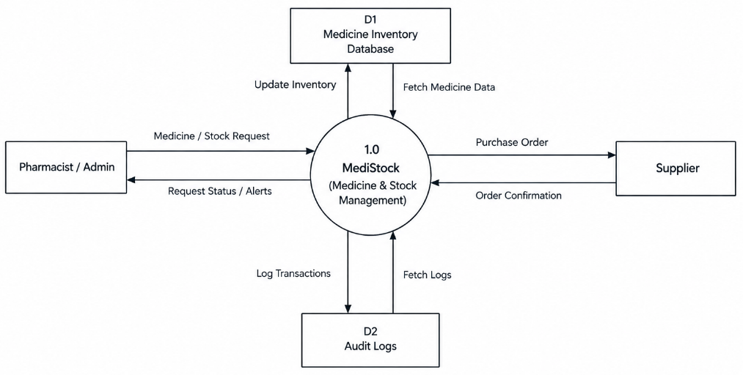
Fig 6.7.3 Data Flow Diagram LEVEL-1
Level-1 DFD shows how medicine and stock requests are processed and how purchase orders are raised to suppliers. Each module updates the inventory status and audit logs.

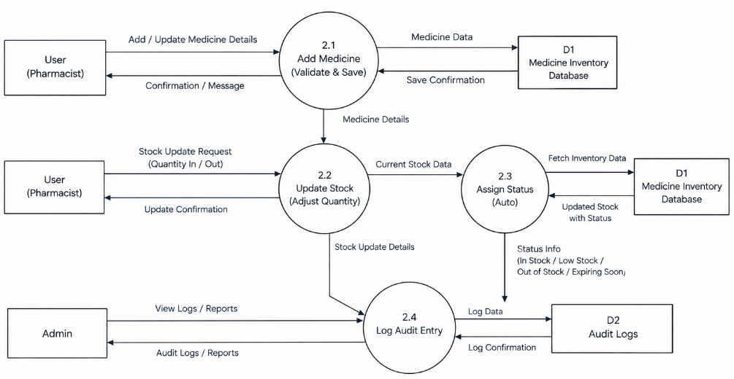
Fig 6.7.4 Data Flow Diagram LEVEL-2
Level-2 DFD shows detailed interactions for adding medicines and updating stock, including automatic status assignment (In Stock, Low Stock, Out of Stock, Expiring Soon) and audit log entries.
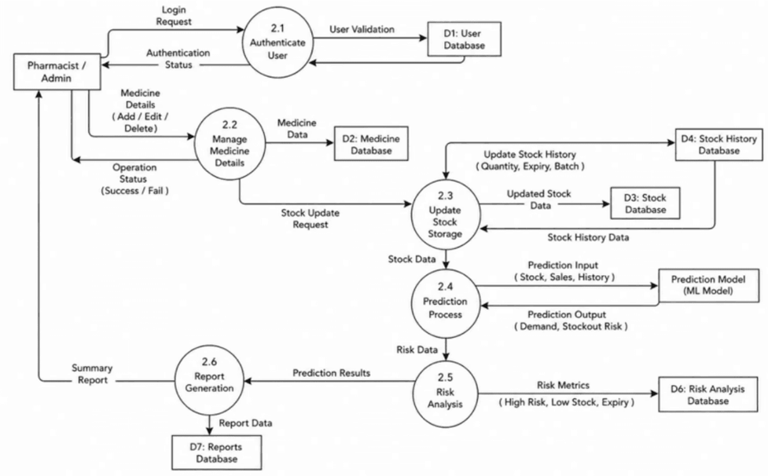
Fig 6.7.5 Data Flow Diagram LEVEL-2
Level-2 DFD shows how historical consumption data is used to compute demand forecasts and shortage-risk scores, and how alerts and reports are produced for the pharmacist.

6.8 DATA DICTIONARY
A data dictionary is a collection of descriptions of the fields or columns in a data collection (MongoDB documents) for the benefit of programmers and others who need to refer to them. The following data dictionary describes the collections used in the MediStock : Medicine Stock Intelligence system.

6.8.1 Collection: medicines
Use: Stores medicine inventory details including stock levels, expiry dates, batch numbers, supplier info, and demand prediction data.
Table 6.8.1 Collection Schema: medicines
Column | Type | Null | Default
_id | ObjectId | No | auto
medicine_id | String (unique) | No
medicine_name | String | No
category | String | No
batch_number | String | No
supplier_email | String | No
stock_quantity | Number | No
minimum_stock | Number | No
reorder_level | Number | No
safety_stock | Number | No
expiry_date | Date | No

6.8.2 Collection: users
Use: Maintains user accounts, roles, permissions, email verification status, and authentication tokens.
Table 6.8.2 Collection Schema: users
Column | Type | Null | Default
_id | ObjectId | No | auto
name | String | No
email | String (unique) | No
password | String (hashed) | No
role | String (enum: 'Admin','Manager','Pharmacist','Cashier','User') | No | User
permissions | Array[String] | Yes | []
emailVerified | Boolean | Yes | false
refreshTokens | Array[String] | Yes | []

6.8.3 Collection: audit_logs
Use: Stores logs of all user activities across modules with timestamps, IP addresses, and action details for compliance tracking.
Table 6.8.3 Collection Schema: audit_logs
Column | Type | Null | Default
_id | ObjectId | No | auto
user | ObjectId (ref: User) | Yes | null
userEmail | String | Yes | null
userRole | String | Yes | null
action | String | No
ip | String | Yes | unknown

6.8.4 Collection: purchase_orders
Use: Stores purchase order records linking medicines and suppliers, including order quantities, status, and delivery tracking.
Table 6.8.4 Collection Schema: purchase_orders
Column | Type | Null | Default
_id | ObjectId | No | auto
medicine_id | ObjectId (ref: Medicine) | No
supplier_email | String | No
quantity_ordered | Number | No
unit_cost | Number | Yes | null
order_date | Date | Yes | now
expected_delivery | Date | Yes | null
status | String (enum) | Yes | Pending
notes | String | Yes | null
created_by | ObjectId (ref: User) | Yes | null

6.8.5 Collection: suppliers
Use: Tracks supplier details, contact information, and active/inactive status for procurement management.
Table 6.8.5 Collection Schema: suppliers
Column | Type | Null | Default
_id | ObjectId | No | auto
supplier_name | String | No
email | String (unique) | No
phone | String | Yes | null
address | String | Yes | null

6.8.6 Collection: categories
Use: Manages medicine category classifications for organized inventory grouping and category-level reporting.
Table 6.8.6 Collection Schema: categories
Column | Type | Null | Default
_id | ObjectId | No | auto
name | String (unique) | No
description | String | Yes | null
medicine_count | Number | Yes | 0
color_code | String | Yes | #4CAF50
status | String (enum) | Yes | Active
created_by | ObjectId (ref: User) | Yes | null
created_at | Date | Yes | now
updated_at | Date | Yes | now

Table 6.8.7 Collection Schema: categories (Type Classification)
Column | Type | Null | Default
_id | ObjectId | No | auto
category_name | String | No
type | String (enum: 'Antibiotic','Analgesic','Vaccine','Controlled','OTC','Other') | No
unit_of_measure | String | Yes | null
description | String | Yes | null
status | Number (0/1) | Yes | 1
created_at | Date | Yes | now

6.8.7 Collection: inventory_movements
Use: Records all stock movements (additions, deductions, transfers) for full traceability of medicine stock changes.
Table 6.8.8 Collection Schema: inventory_movements
Column | Type | Null | Default
_id | ObjectId | No | auto
medicine_id | ObjectId (ref: Medicine) | No
movement_type | String (enum) | No
quantity | Number | Yes | null
previous_stock | Number | Yes | null
new_stock | Number | Yes | null
reason | String | Yes | null
movement_date | Date | Yes | now
performed_by | ObjectId (ref: User) | Yes | null

6.8.8 Collection: reports
Use: Stores generated PDF report metadata for download history and audit trail purposes.
Table 6.8.9 Collection Schema: reports
Column | Type | Null | Default
_id | ObjectId | No | auto
report_type | String | No
file_path | String | No
generated_at | Date | No | now

6.8.9 Collection: forecasts
Use: Stores demand forecasting results including predicted consumption, safety stock calculations, and reorder recommendations.
Table 6.8.10 Collection Schema: forecasts
Column | Type | Null | Default
_id | ObjectId | No | auto
medicine_id | ObjectId (ref: Medicine) | No
predicted_demand | Number | Yes | 0
avg_monthly_consumption | Number | Yes | 0
shortage_risk_score | Number | Yes | 0
reorder_recommendation | String | Yes | null
forecast_date | Date | Yes | now

6.8.10 Collection: settings
Use: Maintains system-wide configuration settings including alert thresholds, email configurations, and user preferences.
Chapter 7
Testing
7.1 Black-Box Testing
7.2 White-Box Testing
7.3 Test Cases
Chapter 7

TESTING
Testing of MediStock combines black-box and white-box approaches to check functionality, security and reliability. Black-box testing verifies the features that users see, such as login, medicine entry, purchase orders, forecasts and reports. White-box testing examines the logic behind those features, such as the stock-status rules, the forecast calculation and the token and role checks. The test cases cover normal use, invalid input and unauthorised access.

7.1 BLACK-BOX TESTING
Black-box testing is a method of software testing that examines the functionality of an application without looking at its internal structure or code. The tester gives inputs through the user interface and compares the outputs with the expected results.
In MediStock, black-box testing was used to validate login, registration with email verification, adding and editing medicines, changing quantities, creating purchase orders, viewing the demand forecast, importing files and downloading reports. Valid, invalid and empty inputs were entered for each form, and the messages, saved records and redirections were checked against the expected behaviour.
Advantages:
- Tests are done from the user's point of view and expose differences from the specification.
- The tester does not need to know the programming language or how the software is implemented.
Disadvantages:
- Only a limited number of inputs can be tried, so some program paths remain untested.

7.2 WHITE-BOX TESTING
White-box testing, also called glass-box or structural testing, is a method in which the internal structure and code of the item being tested are known to the tester. The tester chooses inputs that exercise particular paths, conditions and boundaries in the code and checks the results.
In MediStock, white-box testing concentrated on the rules that drive the system: the conditions that set the stock status when the quantity falls below the reorder level, reaches zero or the expiry date enters the alert window; the calculation of forecast demand and shortage risk; the handling of invalid rows during import; and the middleware that verifies the JWT and the user role before a route runs. Boundary values and invalid tokens were used to confirm that each branch behaves correctly and that errors are handled without breaking the application.
Advantages:
- Testing can start early, without waiting for the user interface to be complete.
- Testing is thorough because most paths and conditions can be covered.
Disadvantages:
- The tests can be complex and need good knowledge of the code.
- Test scripts need maintenance when the implementation changes often.

7.3 TEST CASES
This section records the tests carried out on MediStock: the summary of test types, the test environment, the functional test cases, the non-functional tests, the defects found and the conclusion.

7.3.1 Test Summary
The following table summarises the tests carried out on the MediStock : Medicine Stock Intelligence system.
Table 7.3.1 Testing Report
Sr. | Type of Testing | Report (checked)
1 | Design consistency | ✔
2 | Screen resolution | ✔
3 | Browser compatibility | ✔
4 | Functionality testing – buttons, dropdowns, forms | ✔
5 | Process flow (login -> dashboard -> modules) | ✔
6 | Accessibility (WCAG) | ✔
7 | Mobile responsiveness | ✔
8 | Form input validation & error handling | ✔
9 | JWT session check & token refresh | ✔
10 | API endpoint & link testing | ✔

7.3.2 Test Environment
The system was tested on the same technology stack that is used for development. The environment and tools used during testing are listed in Table 7.3.2.
Table 7.3.2 Test Environment
Item | Details
Frontend | React with Vite, Bootstrap and Chart.js
Backend | Node.js with Express (REST API)
Database | MongoDB accessed through Mongoose
Browsers tested | Google Chrome, Microsoft Edge and Mozilla Firefox (latest versions)
Operating system | Windows
Screen sizes | Desktop, laptop, tablet and mobile widths
API testing | Postman for endpoint and status-code checks
Test data | Sample medicines, categories, suppliers and purchase orders loaded through the CSV/XLSX import feature

7.3.3 Functional Test Cases
Functional testing was carried out module by module. Each test case describes the scenario, the expected behaviour and the outcome observed. The main cases are listed in Table 7.3.3.
Table 7.3.3 Functional Test Cases
ID | Module | Test Scenario | Expected Result | Status
TC-01 | Login | Sign in with a valid email and password | JWT is issued and the user is redirected to the dashboard | Pass
TC-02 | Login | Sign in with a wrong password or unregistered email | Clear error message is shown and no token is issued | Pass
TC-03 | Registration | Register a new user and verify the email link | Account is activated only after email verification | Pass
TC-04 | Medicine | Add a medicine with all valid details | Record is saved, appears in the medicine list and an audit log entry is created | Pass
TC-05 | Medicine | Add a medicine with a missing mandatory field or a negative quantity | Form validation blocks submission and shows a field-level error | Pass
TC-06 | Inventory | Change quantity below reorder level, to zero, and set an expiry date within the alert window | Status changes automatically to Low Stock, Out of Stock and Expiring Soon respectively | Pass
TC-07 | Purchase Order | Create a purchase order for a medicine linked to a supplier and mark it delivered | Order is saved with its status; delivery updates the stock quantity and movement history | Pass
TC-08 | Supplier | Add and edit a supplier | Details are saved and the supplier is available while creating purchase orders | Pass
TC-09 | Import | Upload a valid CSV/XLSX file and a file containing invalid rows | Valid rows are imported; invalid rows are reported without breaking the import | Pass
TC-10 | Forecast | Open the Demand Forecast page for a selected medicine | Forecast chart is rendered from the historical consumption data | Pass
TC-11 | Alerts | Keep medicines below the reorder level or near expiry | Corresponding alerts are displayed on the dashboard and in the alert panel | Pass
TC-12 | Reports | Generate a report and download it as PDF and XLSX | File is downloaded and its contents match the on-screen data | Pass
TC-13 | User Management | Admin adds, edits and deactivates a user; a non-admin opens the same page | Changes are reflected immediately; the non-admin user is denied access | Pass
TC-14 | Audit Logs | Perform create, update and delete actions | Each action is logged with the user, action type and timestamp | Pass
TC-15 | Session | Use the application with an expired or tampered token | Request is rejected and the user is redirected to the login page | Pass

7.3.4 Non-Functional Testing
Along with the functional checks, the qualities that affect day-to-day use of the system were verified. The approach and the observations are summarised in Table 7.3.4.
Table 7.3.4 Non-Functional Testing
Aspect | Method | Observation
Performance | Navigated through the dashboard, medicine list and report pages with the sample data set | Pages loaded and charts rendered without noticeable delay
Security | Accessed protected routes without a token and with a role that lacks permission | Access was denied; passwords are stored in hashed form and routes use JWT and role-based checks
Usability | Completed common tasks (add medicine, raise purchase order, download report) as a new user | Tasks were completed without assistance using the labelled forms and menus
Compatibility | Ran the application in different browsers and screen sizes | Layout and functionality remained consistent
Data integrity | Edited stock and purchase-order records and compared totals with the movement history | Quantities and statuses stayed consistent across screens
Reliability | Repeated create, update and delete operations and refreshed the pages | No data loss or unexpected errors were observed

7.3.5 Defects and Observations
During the testing cycles, minor defects such as alignment problems on smaller screens, unclear validation messages and inconsistent date formatting were identified and corrected. After the fixes, the affected test cases were executed again and passed. No critical or high-severity defect remained open at the end of the final round of testing.

7.3.6 Test Conclusion
All planned test cases were executed and passed. The results show that the authentication, medicine and inventory management, purchase order, supplier, forecasting, alert and reporting modules work as expected for the different user roles, and that the application is stable enough for pilot use in a pharmacy or clinic environment.
Chapter 8
Result and Discussion
8.1 Login, Registration and Email Verification Module
8.2 Dashboard Module
8.3 Medicine Module
8.4 Purchase Order Module
8.5 Supplier Module
8.6 Prediction Module
8.7 Medicine Category Module
8.8 Audit Log Module
8.9 Report and Import / Export Module
8.10 Summary of Results
Chapter 8

RESULT AND DISCUSSION
This chapter describes the working of each module of MediStock and discusses the results observed when the module was tested with the sample data set. The test-case identifiers (TC-01 to TC-15) refer to Table 7.3.3.

8.1 LOGIN, REGISTRATION AND EMAIL VERIFICATION MODULE
The system flow for login, registration, and email verification modules is illustrated in a diagram that serves as a manual for navigating through the portal. New users must verify their email address before gaining access to the inventory dashboard.
If users forget their password but remember their registered email, they can click the 'Forgot Password' link. This opens a form to request a password reset email, which contains a secure token-based link to set a new password.
The following diagram shows the flow of the system for login, registration, and email verification processes:
Result: a valid email and password produced a JWT and redirected the user to the dashboard (TC-01), while a wrong password or an unregistered email showed a clear error and issued no token (TC-02). A newly registered account was activated only after the email link was verified (TC-03), and a request made with an expired or tampered token was rejected and redirected to the login page (TC-15). Administrators could add, edit and deactivate users immediately, while a non-admin user was denied access to the same page (TC-13).

8.2 DASHBOARD MODULE
After logging in to the dashboard, users see the following modules in the navigation bar based on their assigned role (Admin, Manager, Pharmacist, Cashier):
The dashboard is the first screen after login. It gives a live summary of stock metrics, low-stock and expiry alerts, and demand forecast insights, drawn with Chart.js. Result: medicines kept below the reorder level or near expiry produced the corresponding alerts on the dashboard and in the alert panel (TC-11), and the pages and charts loaded without noticeable delay.

8.3 MEDICINE MODULE
The process flow starts with adding medicines with their batch numbers, expiry dates, supplier information, and stock quantity. Automatic status assignment (In Stock, Low Stock, Out of Stock) is handled by the system based on stock thresholds.
The medicine lifecycle follows a four-step model: stock intake, monitoring, alerting, and reporting. Medicines transition through various stock status states as quantities change through sales and restocking.
Result: a medicine with valid details was saved, appeared in the medicine list and created an audit log entry (TC-04), whereas a missing mandatory field or a negative quantity was blocked by form validation with a field-level error (TC-05). Changing the quantity below the reorder level, to zero, or setting an expiry date inside the alert window changed the status automatically to Low Stock, Out of Stock and Expiring Soon (TC-06).

8.4 PURCHASE ORDER MODULE
Purchase orders are crucial in any inventory system, tracking procurement activities to ensure adequate stock levels. This module manages the full purchase order workflow from creation to delivery confirmation.
Result: a purchase order created for a medicine linked to a supplier was saved with its status, and marking it as delivered updated the stock quantity and the movement history (TC-07), so the stock shown on the medicine list and the purchase-order records stayed consistent.

8.5 SUPPLIER MODULE
The supplier management module allows adding, updating, and deactivating supplier records. Active suppliers are highlighted in green, with inactive ones displayed in grey, and quick actions available for editing contact details and creating new purchase orders.
Result: suppliers could be added and edited, and the saved supplier was immediately available while creating purchase orders (TC-08).

8.6 PREDICTION MODULE
The demand prediction module calculates forecast demand for each medicine based on its average monthly consumption, safety stock levels, and lead time. The shortage risk score is computed to prioritize medicines requiring urgent reordering.
Result: opening the Demand Forecast page for a selected medicine rendered the forecast chart from the historical consumption data (TC-10).

8.7 MEDICINE CATEGORY MODULE
Medicine categories (Antibiotics, Analgesics, Vaccines, Controlled Substances, etc.) are essential data maintained up-to-date. New categories are added after validation, and category-level consumption reports are generated automatically.

8.8 AUDIT LOG MODULE
The audit log module auto-generates records of all system activities, including user logins, stock updates, and purchase order changes, helping administrators stay informed and maintain compliance records.
Result: create, update and delete actions were each recorded in the audit log with the user, the type of action and the time stamp (TC-14).

8.9 REPORT AND IMPORT / EXPORT MODULE
This module lets users move data in and out of MediStock. Medicine data can be imported from CSV or XLSX files, and inventory, expiry-analysis and supplier purchase-history reports can be downloaded in PDF and XLSX format. Result: a valid file was imported, while invalid rows were reported without breaking the import (TC-09). Generated reports were downloaded and their contents matched the data on the screen (TC-12).

8.10 SUMMARY OF RESULTS
Table 8.10.1 summarises the results of all modules. All planned test cases passed, and the non-functional tests of performance, security, usability, compatibility, data integrity and reliability gave satisfactory observations.
Table 8.10.1 Summary of Results
Module | Test Cases | Cases Executed | Result
Login, Registration and User Management | TC-01, TC-02, TC-03, TC-13, TC-15 | 5 | Pass
Dashboard and Alerts | TC-11 | 1 | Pass
Medicine Module | TC-04, TC-05, TC-06 | 3 | Pass
Purchase Order Module | TC-07 | 1 | Pass
Supplier Module | TC-08 | 1 | Pass
Prediction Module | TC-10 | 1 | Pass
Audit Log Module | TC-14 | 1 | Pass
Report and Import / Export Module | TC-09, TC-12 | 2 | Pass

Chapter 9
Limitations and Future Enhancement
9.1 Limitations
9.2 Future Enhancement
Chapter 9

LIMITATIONS AND FUTURE ENHANCEMENT

9.1 LIMITATIONS
MediStock is currently a beta version, and it has the following limitations that should be kept in mind when it is used:
- Rule-Based Forecasting: Demand is estimated from average monthly consumption, safety stock and lead time. It does not yet learn seasonal patterns or sudden changes in demand.
- Single Facility: The system manages the inventory of one pharmacy, clinic or hospital dispensary and does not support several branches.
- Manual Data Entry: Stock is entered or updated by users or imported from CSV/XLSX files; there is no barcode scanning to speed this up.
- Web Access Only: The application is used through a web browser and needs a network connection; there is no separate mobile application.
- No External Integration: It is not connected to electronic health record systems or national drug databases, and it does not handle patient records.
- Quality of Data: Forecasts and alerts are only as accurate as the stock, expiry and consumption data entered by the users.
- Pilot-Level Testing: The system has been tested with sample data and is ready for pilot use; it has not yet been tested with long-term data from a live pharmacy.

9.2 FUTURE ENHANCEMENT
Several enhancements can make MediStock more accurate, convenient and widely usable:
- AI-Powered Demand Forecasting: Replace the average-based estimate with machine-learning models that learn from historical consumption and seasonal patterns.
- Predictive Analytics for Seasonal Demand: Anticipate rises in demand for medicines such as those used in seasonal illnesses.
- Integration with National Drug Databases: Fetch standard medicine names, classifications and regulatory information automatically.
- Multi-Branch Pharmacy Support: Manage several pharmacies or stores under one account with stock transfers between branches.
- Mobile Application: Provide an Android and iOS application for stock checks and alerts on the move.
- Barcode Scanning: Update stock quickly and accurately by scanning medicine barcodes.
- EHR Integration: Connect the inventory with electronic health record systems for holistic healthcare management.
These enhancements would further improve the efficiency, accuracy and usability of MediStock for healthcare organisations.
Chapter 10
Conclusion
10.1 Conclusion
Chapter 10

CONCLUSION

10.1 CONCLUSION
Over the course of the internship, significant progress has been made on the MediStock : Medicine Stock Intelligence project, transforming an initial concept into a fully functional, role-based medicine inventory management web application. The system was developed using React, Vite, Node.js, Express, and MongoDB, with Chart.js for data visualization and JWT for authentication.
Key Functionalities:
- Medicine and Inventory Management: Efficiently manage medicines with features like adding, editing, and tracking stock levels with automatic status assignment (In Stock, Low Stock, Out of Stock, Expiring Soon).
- Purchase Order Management: Comprehensive handling of purchase orders with supplier linking, delivery tracking, and invoice management.
- Search and Filter Functionality: Advanced search and filtering capabilities across medicine categories, expiry dates, and stock status for quick data retrieval.
- Dashboard: A user-friendly dashboard providing real-time stock metrics, low-stock alerts, expiry warnings, and demand forecast insights.
- Report Generation: Detailed PDF and XLSX reports for medicine inventory, expiry analysis, and supplier purchase history.
The system has been rigorously tested to ensure reliability and performance across different user roles. Feedback from initial testing revealed strong performance in stock tracking accuracy and report generation quality.
The MediStock : Medicine Stock Intelligence project, developed by Yug Patel as part of an internship, is now ready for deployment in pilot pharmacy and clinic environments, offering a modern, scalable solution for healthcare inventory management.
REFERENCES

REFERENCES
1.Axios (n.d.). Axios HTTP Client Documentation. [online] Available at: https://axios-http.com/
Official documentation of the promise-based HTTP client used by the React frontend to call the Express REST API and to attach JWT tokens to every request through interceptors.
2.Chart.js. Data Visualization Library. [online] chartjs.org. Available at: https://www.chartjs.org/
Documentation of the open-source charting library used to draw the demand forecast, stock level trend and expiry distribution charts on the dashboard.
3.Duckett, J. HTML & CSS design: design and build websites. Indianapolis: John Wiley & Sons, Inc.
A book that explains how to structure web pages with HTML and style them with CSS; it supports the layout of the inventory tables, forms and dashboards.
4.Duckett, J. JavaScript and jQuery. John Wiley & Sons.
A practical guide to client-side JavaScript and jQuery, used as background for the interactive behaviour of the web interface.
5.GitHub. (n.d.). MediStock : Medicine Stock Intelligence Project Repository. [online] Available at: https://github.com/
The source-code hosting platform on which the project repository, its version history and its files are maintained.
6.Infor. (n.d.). Infor CloudSuite Healthcare Supply Chain. [online] Available at: https://www.infor.com/
Vendor material describing a cloud supply-chain suite for healthcare; studied as one of the existing systems in the literature survey.
7.jsPDF. (n.d.). jsPDF – PDF Generation Library for JavaScript. [online] Available at: https://github.com/parallax/jsPDF
Documentation of the JavaScript library used to generate the downloadable PDF reports of medicine inventory and expiry analysis.
8.Marg ERP. (2023). Marg ERP Pharmacy Management Software. [online] Available at: https://www.margbooks.com/
Product information for a pharmacy management and billing software, studied in the literature survey for its purchase, sales, stock and expiry management features.
9.MDN Web Docs. Express / Node.js: server-side web development. Mozilla Foundation. Available at: https://developer.mozilla.org/
A learning resource on server-side web development with Node.js and Express, used as a reference while building the REST API of the system.
10.Medicine Inventory Management Systems: What is an IMS? – ed. [online] – Healthcare Technology Review, available at various academic journals and industry publications.
An overview of what an inventory management system is and how such systems are classified; it supports the discussion of the types of IMS in Chapter 1.
11.Meditech. (n.d.). Meditech Inventory Management. [online] Available at: https://www.meditech.com/
Vendor information on the inventory and supply-chain module of a hospital information system, studied in the literature survey.
12.MongoDB Inc. (n.d.). MongoDB Documentation. [online] Available at: https://www.mongodb.com/docs/
Official documentation of the NoSQL document database used to store medicines, suppliers, purchase orders, users and audit logs.
13.Mongoose. (n.d.). Mongoose ODM Documentation. [online] Available at: https://mongoosejs.com/
Documentation of the object document mapper that defines the schemas and validation rules for the MongoDB collections.
14.Nixon, R. Learning PHP, MySQL, JavaScript, CSS & HTML5: a step-by-step guide to creating dynamic websites. O'Reilly Media.
A step-by-step book on building dynamic websites; used as general background for web development concepts.
15.OpenMRS Community. (2021). OpenMRS Inventory Module – Healthcare Inventory Tracking. Available at: https://openmrs.org/ [Accessed on 28th June 2026].
Community documentation of the open-source medical record platform and its inventory module, studied in the literature survey.
16.Oracle Health. (n.d.). Oracle Cerner Supply Chain Management. [online] Available at: https://www.oracle.com/health/
Vendor information on the supply-chain and inventory tools of a large healthcare platform, studied in the literature survey.
17.PharmAssist. (2020). PharmAssist: Pharmacy Management & Inventory Tracking Software. [online] Available at: https://pharmassist.io/
Product information for pharmacy management and inventory tracking software aimed at small and medium pharmacies, studied in the literature survey.
18.React. (n.d.). React – The library for web and native user interfaces. [online] Available at: https://react.dev/
Official documentation of the component-based JavaScript library used to build the frontend of the system.
19.Stancheva, T. (2023). 45 Groundbreaking Healthcare Inventory Statistics and How to Use Them. [online] Available at: https://healthcare-review.com/
An article collecting statistics on healthcare inventory management; it supports the discussion of the importance of inventory control.
20.Vaidya, P. (2020). Importance of Inventory Management Software in the Digital Transformation of Healthcare. Technology Counter. Available at: https://technologycounter.com/
An article on the benefits of management software in healthcare; the benefits diagram of Chapter 1 is based on it.
21.Vite. (n.d.). Vite Next Generation Frontend Tooling. [online] Available at: https://vitejs.dev/
Documentation of the frontend build tool and development server used to bundle and run the React application.
22.W3Schools (2019). Bootstrap 5 Tutorial. [online] Available at: https://www.w3schools.com/bootstrap5/
A tutorial on the Bootstrap responsive CSS framework used for the layout and components of the interface.
23.W3Schools (2019). JSON Introduction. [online] W3schools.com. Available at: https://www.w3schools.com/js/js_json_intro.asp
A tutorial on the JSON data-interchange format used for all API requests and responses.
24.W3Schools (n.d.). AJAX Introduction. [online] www.w3schools.com. Available at: https://www.w3schools.com/js/js_ajax_intro.asp
A tutorial explaining asynchronous requests from the browser to a server, the basis of the frontend-to-API communication.
25.WHO Essential Medicines. (2023). Model List of Essential Medicines, 23rd Edition. [online] WHO. Available at: https://www.who.int/medicines/
The WHO list of essential medicines, used as background for the medicine categories managed by the system.
26.WHO. (2023). World Health Organization – Medicine Supply and Availability Reports. Available at: https://www.who.int/
Reports from the World Health Organization on the supply and availability of medicines, used as background for the problem statement.
27.XLSX (SheetJS). (n.d.). SheetJS Community Edition – Spreadsheet Data Toolkit. Available at: https://sheetjs.com/
Documentation of the toolkit used to import medicine data from, and export reports to, CSV and XLSX files.
APPENDIX
Appendix A

ABBREVIATIONS
Abbreviations used throughout this document are:
Abbreviation | Meaning
IMS | Inventory Management System
ERP | Enterprise Resource Planning
HR | Human Resources
API | Application Programming Interface
JWT | JSON Web Token
HTML | Hypertext Markup Language
CSS | Cascading Style Sheets
JSON | JavaScript Object Notation
RDBMS | Relational Database Management System
NoSQL | Not Only SQL
ODM | Object Document Mapper
ORM | Object Relational Mapper
UI | User Interface
UX | User Experience
HDD | Hard Disk Drive
RAM | Random-Access Memory
IDE | Integrated Development Environment
PDF | Portable Document Format
XLSX | Microsoft Excel Open XML Spreadsheet
MERN | MongoDB, Express.js, React, Node.js
REST | Representational State Transfer
SDLC | Software Development Life Cycle
STLC | Software Testing Life Cycle
WBS | Work Breakdown Structure
CSV | Comma-Separated Values
EHR | Electronic Health Record

